

**2021**

**TAX RETURN**

**Client:**

**Prepared for:**

**Prepared by:**

**Date:**

**Comments:**

**Route to:**

FDIL2001L 06/09/21

Client Copy

RACHELKO

RACHEL

KOHL COMMUNITY LIBRARY, INC

SMITHBRIDGE RD

687

GLEN MILLS, PA 19342

610-358-3445

Michael J O'Doherty, CPA

MICHAEL

J. O'DOHERTY P.C. CPA

373

BALTIMORE PIKE

SPRINGFIELD, PA 19064

(610) 604-4700

August 19, 2022

**2021 Exempt Org. Return** prepared for:

**RACHEL KOHL COMMUNITY LIBRARY, INC**

687 SMITHBRIDGE RD

GLEN MILLS, PA 19342



**MICHAEL J. O'DOHERTY P.C. CPA**

373 BALTIMORE PIKE

SPRINGFIELD, PA 19064

|  |  |  |  |
| --- | --- | --- | --- |
| **2021 Federal Exempt Organization Tax Summary**  **RACHEL KOHL COMMUNITY LIBRARY, INC** | | | **Page 1**  **23-2127296** |
|  | **2021** | **2020** | **Diff** |
| **REVENUE**  Contributions and grants. . . . . . . . . . . . . . . . . . . . . . . . | 695,250 | 501,223 | 194,027 |
| Program service revenue. . . . . . . . . . . . . . . . . . . . . . . . . . | 16,518 | 14,553 | 1,965 |
| Investment income. . . . . . . . . . . . . . . . . . . . . . . . . . . . . . . . . . . | 220 | 486 | -266 |
| Other revenue. . . . . . . . . . . . . . . . . . . . . . . . . . . . . . . . . . . . . . . . . | 13,093 | 10,834 | 2,259 |
| Total revenue. . . . . . . . . . . . . . . . . . . . . . . . . . . . . . . . . . . . . . . . . | 725,081 | 527,096 | 197,985 |
| **EXPENSES**  Salaries, other compen., emp. benefits. . . | 252,301 | 262,127 | -9,826 |
| Other expenses . . . . . . . . . . . . . . . . . . . . . . . . . . . . . . . . . . . . . . . | 122,641 | 99,788 | 22,853 |
| Total expenses . . . . . . . . . . . . . . . . . . . . . . . . . . . . . . . . . . . . . . . | 374,942 | 361,915 | 13,027 |
| **NET ASSETS OR FUND BALANCES**  Revenue less expenses. . . . . . . . . . . . . . . . . . . . . . . . . . . . . | 350,139 | 165,181 | 184,958 |
| Total assets at end of year. . . . . . . . . . . . . . . . . . . . | 1,095,444 | 809,332 | 286,112 |
| Total liabilities at end of year. . . . . . . . . . . . | 177,928 | 241,955 | -64,027 |
| Net assets/fund balances at end of year. . 917,516 567,377 | | | 350,139 |

|  |  |
| --- | --- |
| **2021 General Information**  **RACHEL KOHL COMMUNITY LIBRARY, INC** | **Page 1**  **23-2127296** |
| **Forms needed for this return**  Federal: 990, Sch A, Sch D, Sch O |  |
| **Carryovers to 2022**  None |  |

|  |
| --- |
| **2021 Preparer e-file Instructions - Federal Page 1**  **RACHEL KOHL COMMUNITY LIBRARY, INC 23-2127296** |
| **The organization's Federal tax return is NOT FINISHED until you complete the following instructions.**  **Prior to transmission of the return**  **Form 990**  The organization should review their Federal Return along with any accompanying schedules and statements.  **Paperless e-file**  The organization should read, sign and date the Form 8879-TE, IRS e-file Signature Authorization.  **Even Return**  No payment is required.  **After transmission of the return**  **Receive acknowledgement of your e-file transmission status.**  Within several hours, connect with Lacerte and get your first acknowledgement (ACK) that Lacerte has received your transmission file.  **Keep a signed copy of Form 8879-TE, IRS e-file Signature Authorization in your files for 3 years.**  Form 8879-TE IRS e-file Signature Authorization  Connect with Lacerte again after 24 and then 48 hours to receive your Federal ACKs.  **Do not mail:** |

|  |
| --- |
| **2021 Preparer e-file Instructions - Federal Page 2**  **RACHEL KOHL COMMUNITY LIBRARY, INC 23-2127296** |
| **The organization's Federal tax return is NOT FINISHED until you complete the following instructions.**  **Prior to transmission of the return**  **Form 8868**  No signature is required with Form 8868.  **Even Return**  No payment is required.  **After transmission of the return**  **Receive acknowledgement of your e-file transmission status.**  Within several hours, connect with Lacerte and get your first acknowledgement (ACK) that Lacerte has received your transmission file.  Connect with Lacerte again after 24 and then 48 hours to receive your Federal ACKs. |

|  |
| --- |
| **2021 Federal Worksheets Page 1**  **RACHEL KOHL COMMUNITY LIBRARY, INC 23-2127296** |
| **Rental Income Worksheet Form 990**  **COMMERCIAL**  Gross Rental Income. . . . . . . . . . . . . . . . . . . . . . . . . . . . . . . . . . . . . . . . . . . . . . . . . . . . . . . . . . . . . . . . . . . . . . . $ 13,093.  Expenses  Total Expenses . . . . . . . . . . . . . . . . . . . . . . . . . . . . . . . . . . . . . . . . . . . . . . . . . . . . . . . . . . . . . . . . . . . . . . . . . . . . $ 0.  Net Rental Income or Loss $ 13,093. |
| **Form 990, Part III, Line 4e**  **Program Services Totals**  Program  Services Total Form 990 Source  Total Expenses 332,923. 332,923. Part IX, Line 25, Col. B  Grants 0. 0. Part IX, Lines 1-3, Col. B  Revenue 0. 16,518. Part VIII, Line 2, Col. A |
| **Form 990, Part IX, Line 24e**  (  A  )  (  B  )  (  C  )  (  D  )  Program  Management  Total  Services  & General  Fundraising  FURNITURE & EQUIPMENT  396.  356.  40.  **Other Expenses**  LIBRARY SUPPLIES 2,092. 2,092.  MISCELLANEOUS 1,588. 1,429. 159. PROFESSIONAL MEMBERSHIPS 880. 880. PROPERTY MANAGEMENT 3,000. 3,000. TELEPHONE 1,853. 1,667. 186.  Total $ 9,809. $ 5,544. $ 4,265. $ 0. |

|  |  |  |  |  |  |
| --- | --- | --- | --- | --- | --- |
| **12/31/21** | **2021 Federal Book Depreciation Schedule**  **RACHEL KOHL COMMUNITY LIBRARY, INC** | |  | **Page 1**  **23-2127296** | |
|  | Prior  Cur Special 179/ Prior Salvage | |  |  | |
|  | Date Date Cost/ | Bus. 179 Depr. Bonus/ Dec. Bal. /Basis Depr. Prior |  |  | Current |
| No. Description  Form 990/990-PF  ____________________  Buildings  _________  1 BUILDING  Total Buildings | Acquired Sold Basis  4/01/10 363,000  363,000 | Pct. Bonus Allow. Sp. Depr. Depr. Reductn Basis Depr. Method  363,000 100,056 S/L HY  0 0 0 0 0 363,000 100,056 | Life  39 | Rate .02564 | Depr. |
| 9,307 |
| 9,307 |
| Improvements  ____________  2 DESK AND BATHROOM RENOVATI | 4/17/20 6,585 | 6,585 170 S/L MM | 27.5 | .03636 | 239 |
| 3 HVAC SYSTEM  Total Improvements  Total Depreciation  Grand Total Depreciation | 5/31/20 198,352  204,937  567,937  567,937 | 198,352  4,509  S/L MM  0  0  0  0  0  204,937  4,679  0  0  0  0  0  567,937  104,735  0  0  0  0  0  567,937  104,735 | 27.5 | .03636 | 7,212 |
| 7,451 |
| 16,758 |
| 16,758 |
|  |

|  |  |  |  |
| --- | --- | --- | --- |
| Form **8879-TE** | **IRS *e-file* Signature Authorization for a Tax Exempt Entity** | | OMB No. 1545-0047 |
|  |
| Department of the Treasury | For calendar year 2021, or fiscal year beginning , 2021, and ending , 20  G **Do not send to the IRS. Keep for your records.** | | **2021** |
| Internal Revenue Service | G **Go to *www.irs.gov/Form8879TE* for the latest information.** | |  |
| Name of filer | | **EIN or SSN** |  |
| RACHEL KOHL COMMUNITY LIBRARY, INC | | 23-2127296 |  |

Name and title of officer or person subject to tax

JENNIFER PANARO Treasurer

|  |  |
| --- | --- |
| **Part I** | **Type of Return and Return Information** |

Check the box for the return for which you are using this Form 8879-TE and enter the applicable amount, if any, from the return. Form 8038-CP and Form 5330 filers may enter dollars and cents. For all other forms, enter whole dollars only. If you check the box on line **1a, 2a, 3a, 4a, 5a, 6a, 7a, 8a, 9a,** or **10a** below, and the amount on that line for the return being filed with this form was blank, then leave line **1b, 2b, 3b, 4b, 5b, 6b, 7b, 8b, 9b,** or **10b,** whichever is applicable, blank (do not enter -0-). But, if you entered -0- on the return, then enter -0- on the applicable line below. **Do not** complete more than one line in Part I.

**1a Form 990** check here. . . . . . G**b Total revenue,** if any (Form 990, Part VIII, column (A), line 12). . . . . . . . . . . . **1b** 725,081.

X

**2a Form 990-EZ** check here . . G**b Total revenue,** if any (Form 990-EZ, line 9). . . . . . . . . . . . . . . . . . . . . . . . . . . . . . . **2b**

**3a Form 1120-POL** check hereG**b Total tax** (Form 1120-POL, line 22) . . . . . . . . . . . . . . . . . . . . . . . . . . . . . . . . . . . . . . **3b**

**4a Form 990-PF** check here . . G**b Tax based on investment income** (Form 990-PF, Part V, line 5). . . . . . . . . . . **4b**

**5a Form 8868** check here. . . . . G**b Balance due** (Form 8868, line 3c). . . . . . . . . . . . . . . . . . . . . . . . . . . . . . . . . . . . . . . . **5b**

**6a Form 990-T** check here. . . . G**b Total tax** (Form 990-T, Part III, line 4). . . . . . . . . . . . . . . . . . . . . . . . . . . . . . . . . . . . **6b**

**7a Form 4720** check here. . . . . G**b Total tax** (Form 4720, Part III, line 1). . . . . . . . . . . . . . . . . . . . . . . . . . . . . . . . . . . . . **7b**

**8a Form 5227** check here. . . . . G**b FMV of assets at end of tax year** (Form 5227, Item D). . . . . . . . . . . . . . . . . . . . . **8b**

**9a Form 5330** check here. . . . . G**b Tax due** (Form 5330, Part II, line 19). . . . . . . . . . . . . . . . . . . . . . . . . . . . . . . . . . . . . **9b**

**10a Form 8038-CP** check here. G**b Amount of credit payment requested** (Form 8038-CP, Part III, line 22). . . . **10b**

|  |  |
| --- | --- |
| **Part II** | **Declaration and Signature Authorization of Officer or Person Subject to Tax** |

Under penalties of perjury, I declare that X I am an officer of the above entity or I am a person subject to tax with respect to

(name of entity) , (EIN)

and that I have examined a copy of the 2021 electronic return and accompanying schedules and statements, and, to the best of my knowledge and belief, they are true, correct, and complete. I further declare that the amount in Part I above is the amount shown on the copy of the electronic return. I consent to allow my intermediate service provider, transmitter, or electronic return originator (ERO) to send the return to the IRS and to receive from the IRS **(a)** an acknowledgement of receipt or reason for rejection of the transmission, **(b)** the reason for any delay in

processing the return or refund, and **(c)** the date of any refund. If applicable, I authorize the U.S. Treasury and its designated Financial Agent to initiate an electronic funds withdrawal (direct debit) entry to the financial institution account indicated in the tax preparation software for payment

of the federal taxes owed on this return, and the financial institution to debit the entry to this account. To revoke a payment, I must contact the U.S. Treasury Financial Agent at 1-888-353-4537 no later than 2 business days prior to the payment (settlement) date. I also authorize the financial institutions involved in the processing of the electronic payment of taxes to receive confidential information necessary to answer inquiries and resolve issues related to the payment. I have selected a personal identification number (PIN) as my signature for the electronic return and, if applicable, the consent to electronic funds withdrawal.



**PIN: check one box only**

|  |
| --- |
| 81385 |

X I authorize MICHAEL J. O'DOHERTY P.C. CPA to enter my PINas my signature

**ERO firm name Enter five numbers, but do not enter all zeros** on the tax year 2021 electronically filed return. If I have indicated within this return that a copy of the return is being filed with a state agency(ies) regulating charities as part of the IRS Fed/State program, I also authorize the aforementioned ERO to enter my PIN on the return's disclosure consent screen.

As an officer or person subject to tax with respect to the entity, I will enter my PIN as my signature on the tax year 2021 electronically filed return. If I have indicated within this return that a copy of the return is being filed with a state agency(ies) regulating charities as part of the IRS Fed/State program, I will enter my PIN on the return's disclosure consent screen.

Signature of officer or person subject to tax G Date G

|  |  |
| --- | --- |
| **Part III** | **Certification and Authentication** |

|  |
| --- |
| 23342721801 |

**ERO's EFIN/PIN.** Enter your six-digit electronic filing identification number (EFIN) followed by your five-digit self-selected PIN.

# Do not enter all zeros

I certify that the above numeric entry is my PIN, which is my signature on the 2021 electronically filed return indicated above. I confirm that I am submitting this return in accordance with the requirements of **Pub. 4163,** Modernized e-File (MeF) Information for Authorized IRS *e-file* Providers for Business Returns.

ERO's signature G Michael J O'Doherty, CPA DateG 8/15/2022

**ERO Must Retain This Form** ' **See Instructions**

# Do Not Submit This Form to the IRS Unless Requested To Do So

**BAA For Privacy and Paperwork Reduction Act Notice, see instructions.** TEEA8800L 11/29/21 Form **8879-TE** (2021)

|  |  |  |
| --- | --- | --- |
| Form **990** | **Return of Organization Exempt From Income Tax** | OMB No. 1545-0047 |
| **2021** |
| Department of the Treasury Internal Revenue Service | **Under section 501(c), 527, or 4947(a)(1) of the Internal Revenue Code (except private foundations)**  G **Do not enter social security numbers on this form as it may be made public.**  G **Go to *www.irs.gov/Form990* for instructions and the latest information.** |  |
| **Open to Public Inspection** |

1. **For the 2021 calendar year, or tax year beginning , 2021, and ending , 20**
2. Check if applicable: **C D Employer identification number**

Address change RACHEL KOHL COMMUNITY LIBRARY, INC 23-2127296

Name change 687 SMITHBRIDGE RD **E** Telephone number

Initial return GLEN MILLS, PA 19342 610-358-3445

Final return/terminated

Amended return **G** Gross receipts $ 725,081.

Application pending **F** Name and address of principal officer: **H(a)** Is this a group return for subordinates? **Yes** X **No**

Same As C Above **H(b)** Are all subordinates included?If "No," attach a list. See instructions. **Yes No I** Tax-exempt status: X 501(c)(3) 501(c) ( )H (insert no.) 4947(a)(1) or 527

1. **Website:** G N/A **H(c)** Group exemption number G
2. Form of organization: X Corporation Trust Association OtherG **L** Year of formation: **M** State of legal domicile: PA

# Part I Summary

1. Briefly describe the organization's mission or most significant activities: See Schedule O
2. Check this box G if the organization discontinued its operations or disposed of more than 25% of its net assets.
3. Number of voting members of the governing body (Part VI, line 1a) . . . . . . . . . . . . . . . . . . . . . . . . . . . . . . . . . . . **3** 9 **4** Number of independent voting members of the governing body (Part VI, line 1b). . . . . . . . . . . . . . . . . . . . . . . **4** 0 **5** Total number of individuals employed in calendar year 2021 (Part V, line 2a) . . . . . . . . . . . . . . . . . . . . . . . . . . **5** 0 **6** Total number of volunteers (estimate if necessary). . . . . . . . . . . . . . . . . . . . . . . . . . . . . . . . . . . . . . . . . . . . . . . . . . . **6** 0

**7a** Total unrelated business revenue from Part VIII, column (C), line 12. . . . . . . . . . . . . . . . . . . . . . . . . . . . . . . . . . . **7a** 0. **b** Net unrelated business taxable income from Form 990-T, Part I, line 11 . . . . . . . . . . . . . . . . . . . . . . . . . . . . . . . **7b** 0.

**Prior Year Current Year**

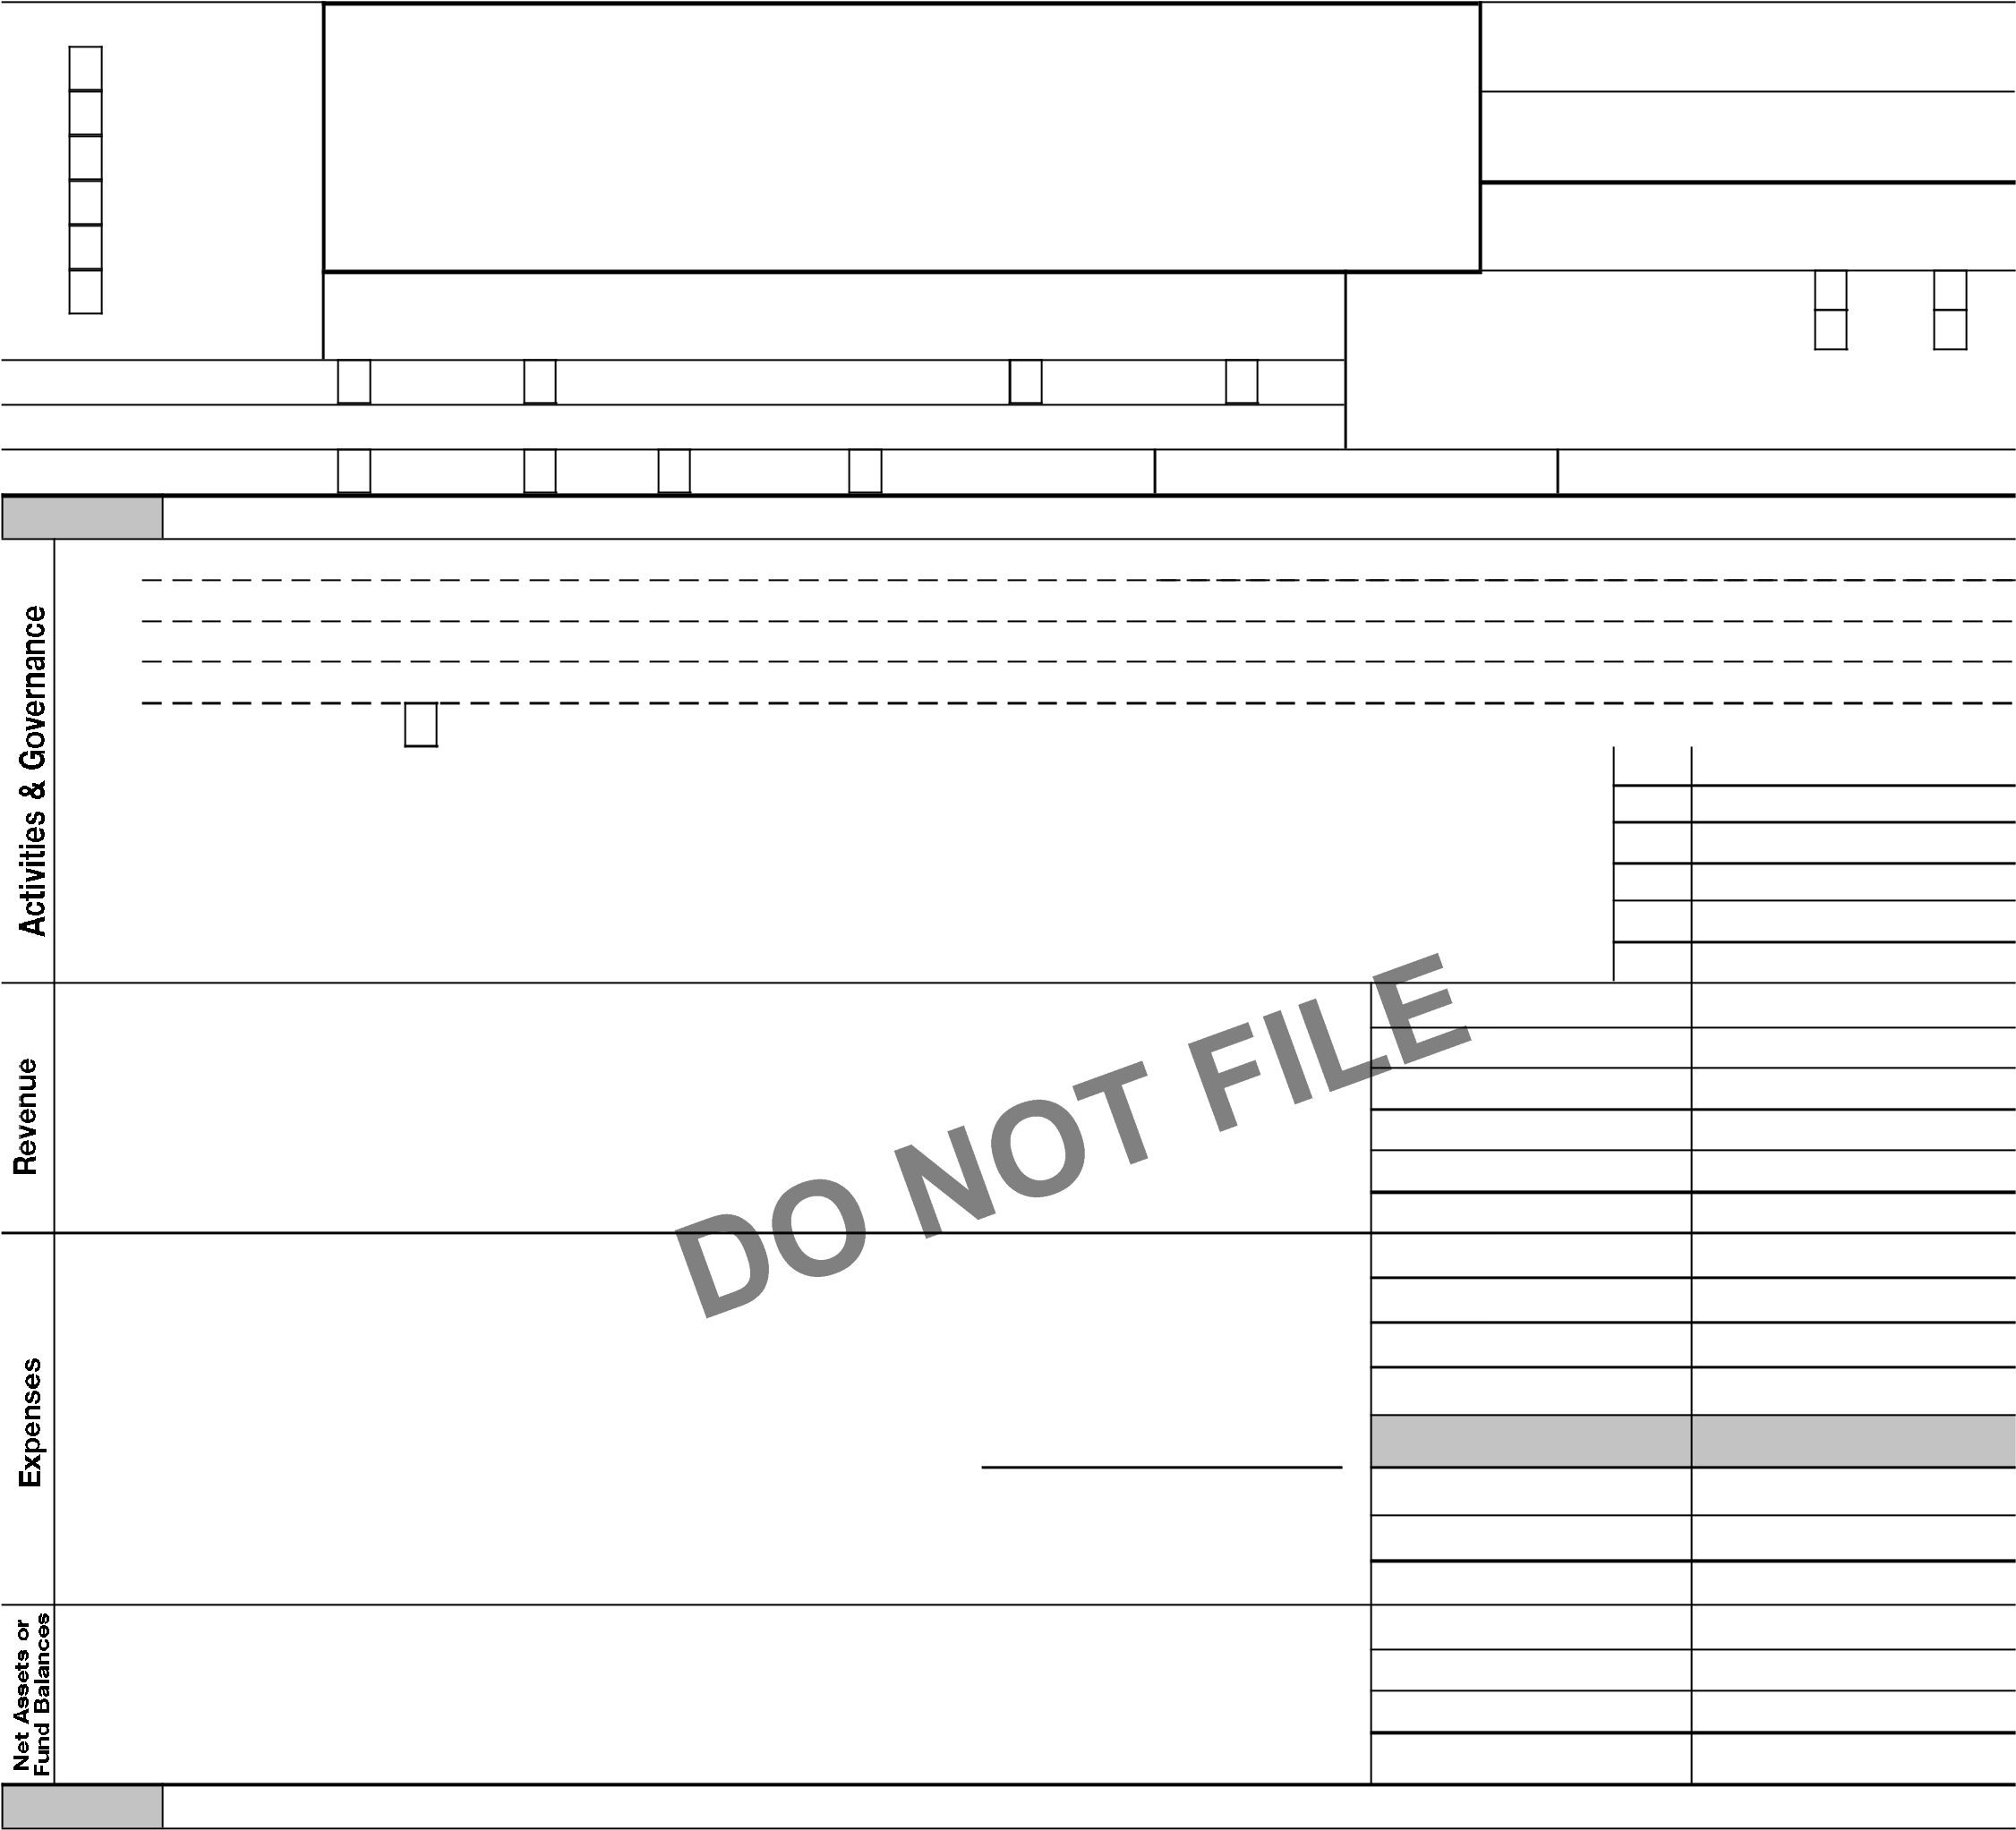**8** Contributions and grants (Part VIII, line 1h). . . . . . . . . . . . . . . . . . . . . . . . . . . . . . . . . . . . . . . . . . 501,223. 695,250. **9** Program service revenue (Part VIII, line 2g). . . . . . . . . . . . . . . . . . . . . . . . . . . . . . . . . . . . . . . . . . 14,553. 16,518. **10** Investment income (Part VIII, column (A), lines 3, 4, and 7d) . . . . . . . . . . . . . . . . . . . . . . . . . 486. 220. **11** Other revenue (Part VIII, column (A), lines 5, 6d, 8c, 9c, 10c, and 11e). . . . . . . . . . . . . . . . 10,834. 13,093. **12** Total revenue ' add lines 8 through 11 (must equal Part VIII, column (A), line 12). . . . . 527,096. 725,081.

1. Grants and similar amounts paid (Part IX, column (A), lines 1-3). . . . . . . . . . . . . . . . . . . . . .
2. Benefits paid to or for members (Part IX, column (A), line 4). . . . . . . . . . . . . . . . . . . . . . . . . .
3. Salaries, other compensation, employee benefits (Part IX, column (A), lines 5-10). . . . . . 262,127. 252,301.

**16a** Professional fundraising fees (Part IX, column (A), line 11e). . . . . . . . . . . . . . . . . . . . . . . . . . **b** Total fundraising expenses (Part IX, column (D), line 25) G 4,807.

1. Other expenses (Part IX, column (A), lines 11a-11d, 11f-24e). . . . . . . . . . . . . . . . . . . . . . . . . 99,788. 122,641.
2. Total expenses. Add lines 13-17 (must equal Part IX, column (A), line 25). . . . . . . . . . . . . 361,915. 374,942.
3. Revenue less expenses. Subtract line 18 from line 12 . . . . . . . . . . . . . . . . . . . . . . . . . . . . . . . . 165,181. 350,139. **Beginning of Current Year End of Year**
4. Total assets (Part X, line 16). . . . . . . . . . . . . . . . . . . . . . . . . . . . . . . . . . . . . . . . . . . . . . . . . . . . . . . . 809,332. 1,095,444. **21** Total liabilities (Part X, line 26) . . . . . . . . . . . . . . . . . . . . . . . . . . . . . . . . . . . . . . . . . . . . . . . . . . . . . 241,955. 177,928.

**22** Net assets or fund balances. Subtract line 21 from line 20. . . . . . . . . . . . . . . . . . . . . . . . . . . . 567,377. 917,516.

# Part II Signature Block

Under penalties of perjury, I declare that I have examined this return, including accompanying schedules and statements, and to the best of my knowledge and belief, it is true, correct, and complete. Declaration of preparer (other than officer) is based on all information of which preparer has any knowledge.

|  |  |  |  |  |  |  |  |  |  |  |  |  |
| --- | --- | --- | --- | --- | --- | --- | --- | --- | --- | --- | --- | --- |
| **Sign** | A | | |  | | | | | | |  | |
| Signature of officer Date | | | | | | | | | |  | |
| **Here** | A JENNIFER PANARO Treasurer | | | | | | | | | |  | |
| Type or print name and title | | | | | | | | | |  | |
| **Paid**  **Preparer**  **Use Only** | Print/Type preparer's name  Michael J O'Doherty, CPA | Preparer's signature  Michael J O'Doherty, CPA | Date | | Check self-employed |  | if | PTIN  P00160409 | | |  | |
|  |
| Firm's name G MICHAEL J. O'DOHERTY P.C. CPA | | | | Firm's EIN G 23-2730769 | | | | | |  | |
| Firm's address G 373 BALTIMORE PIKE | | | |
| SPRINGFIELD, PA 19064 | | | | Phone no. (610) 604-4700 | | | | | |  | |
| May the IRS discuss this return with the preparer shown above? See instructions. . . . . . . . . . . . . . . . . . . . . . . . . . . . . . . . . . . . . . . . | | | | | | | | | X | **Yes** |  | **No** |

**BAA For Paperwork Reduction Act Notice, see the separate instructions.** TEEA0101L 09/22/21 Form **990** (2021) Form 990 (2021)

|  |  |
| --- | --- |
| **Part III** | **Statement of Program Service Accomplishments**  Check if Schedule O contains a response or note to any line in this Part III. . . . . . . . . . . . . . . . . . . . . . . . . . . . . . . . . . . . . . . . . . . . . . . . . . X |
|  |

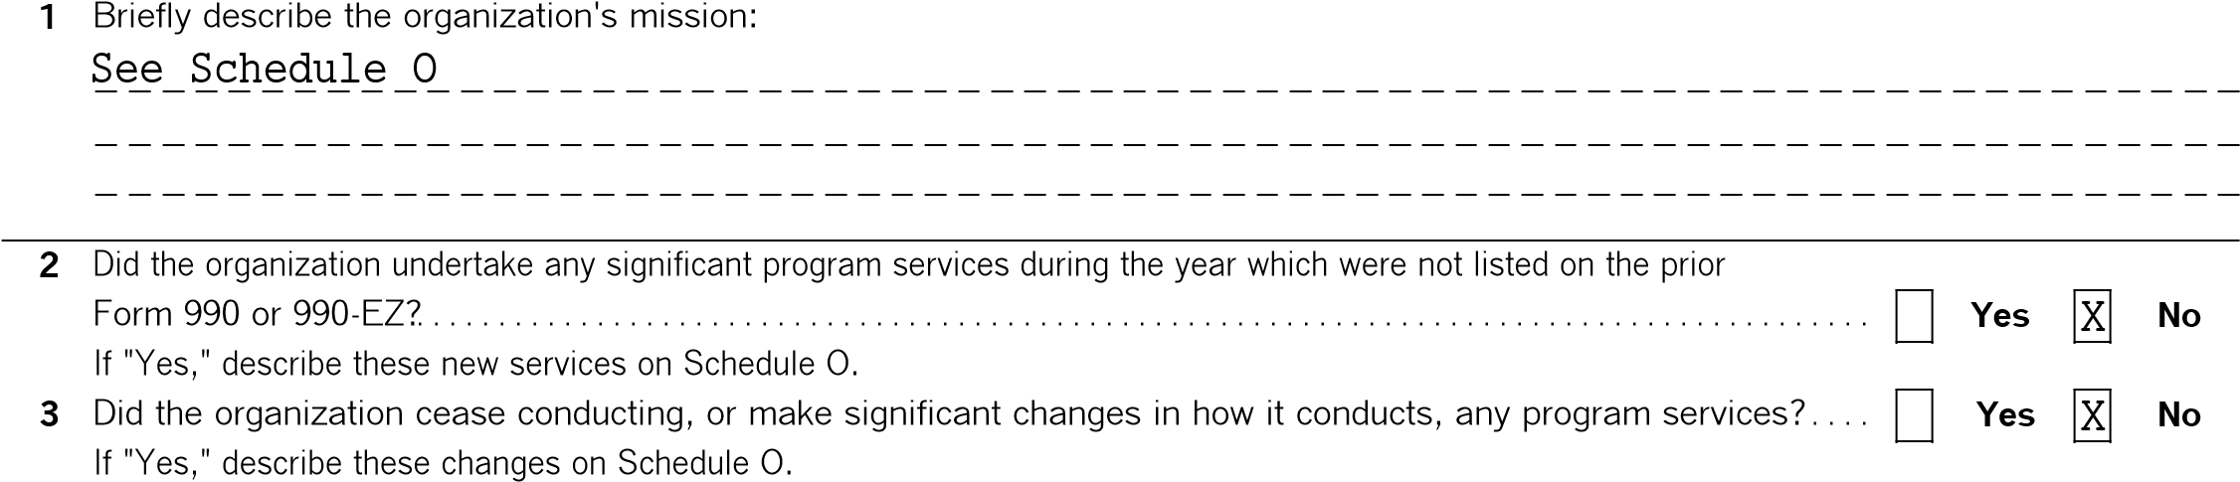

**4** Describe the organization's program service accomplishments for each of its three largest program services, as measured by expenses. Section 501(c)(3) and 501(c)(4) organizations are required to report the amount of grants and allocations to others, the total expenses, and revenue, if any, for each program service reported.



|  |  |  |  |
| --- | --- | --- | --- |
| **4d** Other program services (Describe on Schedule O.)  (Expenses $ including grants of $ | ) (Revenue | $ | ) |
| **4e** Total program service expenses G 332,923. |  |  |  |

**BAA** TEEA0102L 09/22/21 Form **990** (2021)

Page

|  |  |  |  |  |  |
| --- | --- | --- | --- | --- | --- |
| **Part IV** | **Checklist of Required Schedules** | | | | |
|  | | | **Yes** | **No** | |
| 1. Is the organization described in section 501(c)(3) or 4947(a)(1) (other than a private foundation)? *If 'Yes,' complete*   *Schedule A*. . . . . . . . . . . . . . . . . . . . . . . . . . . . . . . . . . . . . . . . . . . . . . . . . . . . . . . . . . . . . . . . . . . . . . . . . . . . . . . . . . . . . . . . . . . . . . . . . . . . . . .   1. Is the organization required to complete *Schedule B, Schedule of Contributors*? See instructions. . . . . . . . . . . . . . . . . . . . . . . 2. Did the organization engage in direct or indirect political campaign activities on behalf of or in opposition to candidates   for public office? *If 'Yes,' complete Schedule C, Part I*. . . . . . . . . . . . . . . . . . . . . . . . . . . . . . . . . . . . . . . . . . . . . . . . . . . . . . . . . . . . . . .   1. **Section 501(c)(3) organizations.** Did the organization engage in lobbying activities, or have a section 501(h) election   in effect during the tax year? *If 'Yes,' complete Schedule C, Part II*. . . . . . . . . . . . . . . . . . . . . . . . . . . . . . . . . . . . . . . . . . . . . . . . . . .   1. Is the organization a section 501(c)(4), 501(c)(5), or 501(c)(6) organization that receives membership dues, assessments, or similar amounts as defined in Revenue Procedure 98-19? *If 'Yes,' complete Schedule C, Part III*. . . . . . . 2. Did the organization maintain any donor advised funds or any similar funds or accounts for which donors have the right to provide advice on the distribution or investment of amounts in such funds or accounts? *If 'Yes,' complete Schedule D,*   *Part I* . . . . . . . . . . . . . . . . . . . . . . . . . . . . . . . . . . . . . . . . . . . . . . . . . . . . . . . . . . . . . . . . . . . . . . . . . . . . . . . . . . . . . . . . . . . . . . . . . . . . . . . . . . . .   1. Did the organization receive or hold a conservation easement, including easements to preserve open space, the environment, historic land areas, or historic structures? *If 'Yes,' complete Schedule D, Part II*. . . . . . . . . . . . . . . . . . . . . . . . . . 2. Did the organization maintain collections of works of art, historical treasures, or other similar assets? *If 'Yes,'*   *complete Schedule D, Part III*. . . . . . . . . . . . . . . . . . . . . . . . . . . . . . . . . . . . . . . . . . . . . . . . . . . . . . . . . . . . . . . . . . . . . . . . . . . . . . . . . . . . . .   1. Did the organization report an amount in Part X, line 21, for escrow or custodial account liability, serve as a custodian for amounts not listed in Part X; or provide credit counseling, debt management, credit repair, or debt negotiation services? *If 'Yes,' complete Schedule D, Part IV*. . . . . . . . . . . . . . . . . . . . . . . . . . . . . . . . . . . . . . . . . . . . . . . . . . . . . . . . . . . . . . . . . . . . 2. Did the organization, directly or through a related organization, hold assets in donor-restricted endowments   or in quasi endowments? *If 'Yes,' complete Schedule D, Part V*. . . . . . . . . . . . . . . . . . . . . . . . . . . . . . . . . . . . . . . . . . . . . . . . . . . . . .   1. If the organization's answer to any of the following questions is 'Yes', then complete Schedule D, Parts VI, VII, VIII, IX, or X, as applicable.   **a** Did the organization report an amount for land, buildings, and equipment in Part X, line 10? *If 'Yes,' complete Schedule*  *D, Part VI*. . . . . . . . . . . . . . . . . . . . . . . . . . . . . . . . . . . . . . . . . . . . . . . . . . . . . . . . . . . . . . . . . . . . . . . . . . . . . . . . . . . . . . . . . . . . . . . . . . . . . . . . **b** Did the organization report an amount for investments ' other securities in Part X, line 12, that is 5% or more of its total assets reported in Part X, line 16? *If 'Yes,' complete Schedule D, Part VII*. . . . . . . . . . . . . . . . . . . . . . . . . . . . . . . . . . . . . . . . . . . .   1. Did the organization report an amount for investments ' program related in Part X, line 13, that is 5% or more of its total assets reported in Part X, line 16? *If 'Yes,' complete Schedule D, Part VIII* . . . . . . . . . . . . . . . . . . . . . . . . . . . . . . . . . . . . . . . . . . . 2. Did the organization report an amount for other assets in Part X, line 15, that is 5% or more of its total assets reported in Part X, line 16? *If 'Yes,' complete Schedule D, Part IX*. . . . . . . . . . . . . . . . . . . . . . . . . . . . . . . . . . . . . . . . . . . . . . . . . . . . . . . . . . . . **e** Did the organization report an amount for other liabilities in Part X, line 25? *If 'Yes,' complete Schedule D, Part X*. . . . . .   **f** Did the organization's separate or consolidated financial statements for the tax year include a footnote that addresses the organization's liability for uncertain tax positions under FIN 48 (ASC 740)? *If 'Yes,' complete Schedule D, Part X*. . . .  **12a** Did the organization obtain separate, independent audited financial statements for the tax year? *If 'Yes,' complete*  *Schedule D, Parts XI and XII* . . . . . . . . . . . . . . . . . . . . . . . . . . . . . . . . . . . . . . . . . . . . . . . . . . . . . . . . . . . . . . . . . . . . . . . . . . . . . . . . . . . . . . **b** Was the organization included in consolidated, independent audited financial statements for the tax year? *If 'Yes,' and if the organization answered 'No' to line 12a, then completing Schedule D, Parts XI and XII is optional*. . . . . . . . . . . . . . . . . **13** Is the organization a school described in section 170(b)(1)(A)(ii)? *If 'Yes,' complete Schedule E* . . . . . . . . . . . . . . . . . . . . . . .  **14a** Did the organization maintain an office, employees, or agents outside of the United States?. . . . . . . . . . . . . . . . . . . . . . . . . . .  **b** Did the organization have aggregate revenues or expenses of more than $10,000 from grantmaking, fundraising, business, investment, and program service activities outside the United States, or aggregate foreign investments valued at $100,000 or more? *If 'Yes,' complete Schedule F, Parts I and IV* . . . . . . . . . . . . . . . . . . . . . . . . . . . . . . . . . . . . . . . . . . . . . . . . . .   1. Did the organization report on Part IX, column (A), line 3, more than $5,000 of grants or other assistance to or for any   foreign organization? *If 'Yes,' complete Schedule F, Parts II and IV*. . . . . . . . . . . . . . . . . . . . . . . . . . . . . . . . . . . . . . . . . . . . . . . . . .   1. Did the organization report on Part IX, column (A), line 3, more than $5,000 of aggregate grants or other assistance to   or for foreign individuals? *If 'Yes,' complete Schedule F, Parts III and IV* . . . . . . . . . . . . . . . . . . . . . . . . . . . . . . . . . . . . . . . . . . . . .   1. Did the organization report a total of more than $15,000 of expenses for professional fundraising services on Part IX, column (A), lines 6 and 11e? *If 'Yes,' complete Schedule G, Part I*. See instructions . . . . . . . . . . . . . . . . . . . . . . . . . . . . . . . . . . 2. Did the organization report more than $15,000 total of fundraising event gross income and contributions on Part VIII,   lines 1c and 8a? *If 'Yes,' complete Schedule G, Part II*. . . . . . . . . . . . . . . . . . . . . . . . . . . . . . . . . . . . . . . . . . . . . . . . . . . . . . . . . . . . . .   1. Did the organization report more than $15,000 of gross income from gaming activities on Part VIII, line 9a? *If 'Yes,'*   *complete Schedule G, Part III*. . . . . . . . . . . . . . . . . . . . . . . . . . . . . . . . . . . . . . . . . . . . . . . . . . . . . . . . . . . . . . . . . . . . . . . . . . . . . . . . . . . . . .  **20a** Did the organization operate one or more hospital facilities? *If 'Yes,' complete Schedule H*. . . . . . . . . . . . . . . . . . . . . . . . . . . .  **b** If 'Yes' to line 20a, did the organization attach a copy of its audited financial statements to this return? . . . . . . . . . . . . . . . .  **21** Did the organization report more than $5,000 of grants or other assistance to any domestic organization or domestic government on Part IX, column (A), line 1? *If 'Yes,' complete Schedule I, Parts I and II*. . . . . . . . . . . . . . . . . . . . . . | | **1** | X |  | |
| **2** |  | X | |
| **3** |  | X | |
| **4** |  | X | |
| **5** |  | X | |
| **6** |  | X | |
| **7** |  | X | |
| **8** |  | X | |
| **9** |  | X | |
| **10** |  | X | |
|  |  |  |  |
| **11a** | X |  |
| **11b** |  | X |
| **11c** |  | X |
| **11d** |  | X |
| **11e** | X |  |
| **11f** |  | X |
| **12a** |  | X |
| **12b** |  | X |
| **13** |  | X |
| **14a** |  | X |
| **14b** |  | X |
| **15** |  | X |
| **16** |  | X |
| **17** |  | X |
| **18** |  | X |
| **19** |  | X |
| **20a** |  | X | |
| **20b** |  |  | |
| **21** |  | X | |

**BAA** TEEA0103L 09/22/21 Form **990** (2021)

|  |  |  |  |  |  |  |  |  |  |
| --- | --- | --- | --- | --- | --- | --- | --- | --- | --- |
| **Part IV** | | **Checklist of Required Schedules** *(continued)* | | | | | | | |
|  | | | | | | **Yes** | **No** | | |
| 1. Did the organization report more than $5,000 of grants or other assistance to or for domestic individuals on Part IX,   column (A), line 2? *If 'Yes,' complete Schedule I, Parts I and III* . . . . . . . . . . . . . . . . . . . . . . . . . . . . . . . . . . . . . . . . . . . . . . . . . . . . .   1. Did the organization answer 'Yes' to Part VII, Section A, line 3, 4, or 5, about compensation of the organization's current and former officers, directors, trustees, key employees, and highest compensated employees? *If 'Yes,' complete*   *Schedule J*. . . . . . . . . . . . . . . . . . . . . . . . . . . . . . . . . . . . . . . . . . . . . . . . . . . . . . . . . . . . . . . . . . . . . . . . . . . . . . . . . . . . . . . . . . . . . . . . . . . . . . .  **24a** Did the organization have a tax-exempt bond issue with an outstanding principal amount of more than $100,000 as of the last day of the year, that was issued after December 31, 2002? *If 'Yes,' answer lines 24b through 24d and complete Schedule K. If 'No, 'go to line 25a* . . . . . . . . . . . . . . . . . . . . . . . . . . . . . . . . . . . . . . . . . . . . . . . . . . . . . . . . . . . . . . . . . . . . . . . . **b** Did the organization invest any proceeds of tax-exempt bonds beyond a temporary period exception?. . . . . . . . . . . . . . . . . .  **c** Did the organization maintain an escrow account other than a refunding escrow at any time during the year to defease any tax-exempt bonds? . . . . . . . . . . . . . . . . . . . . . . . . . . . . . . . . . . . . . . . . . . . . . . . . . . . . . . . . . . . . . . . . . . . . . . . . . . . . . . . . . . . . . . . . . . . **d** Did the organization act as an 'on behalf of' issuer for bonds outstanding at any time during the year?. . . . . . . . . . . . . . . . .  **25a Section 501(c)(3), 501(c)(4), and 501(c)(29) organizations.** Did the organization engage in an excess benefit  transaction with a disqualified person during the year? *If 'Yes,' complete Schedule L, Part I* . . . . . . . . . . . . . . . . . . . . . . . . . . .  **b** Is the organization aware that it engaged in an excess benefit transaction with a disqualified person in a prior year, and that the transaction has not been reported on any of the organization's prior Forms 990 or 990-EZ? *If 'Yes,' complete*  *Schedule L, Part I*. . . . . . . . . . . . . . . . . . . . . . . . . . . . . . . . . . . . . . . . . . . . . . . . . . . . . . . . . . . . . . . . . . . . . . . . . . . . . . . . . . . . . . . . . . . . . . . . .   1. Did the organization report any amount on Part X, line 5 or 22, for receivables from or payables to any current or former officer, director, trustee, key employee, creator or founder, substantial contributor, or 35% controlled entity or family member of any of these persons? *If 'Yes,' complete Schedule L, Part II*. . . . . . . . . . . . . . . . . . . . . . . . . . . . . . . . . . . . . 2. Did the organization provide a grant or other assistance to any current or former officer, director, trustee, key employee, creator or founder, substantial contributor or employee thereof, a grant selection committee member, or to a 35% controlled entity (including an employee thereof) or family member of any of these persons? *If 'Yes,' complete Schedule L, Part III*. . . . . . . . . . . . . . . . . . . . . . . . . . . . . . . . . . . . . . . . . . . . . . . . . . . . . . . . . . . . . . . . . . . . . 3. Was the organization a party to a business transaction with one of the following parties (see the Schedule L, Part IV, instructions for applicable filing thresholds, conditions, and exceptions):    1. A current or former officer, director, trustee, key employee, creator or founder, or substantial contributor? *If*   *'Yes,' complete Schedule L, Part IV*. . . . . . . . . . . . . . . . . . . . . . . . . . . . . . . . . . . . . . . . . . . . . . . . . . . . . . . . . . . . . . . . . . . . . . . . . . . . . . . . **b** A family member of any individual described in line 28a? *If 'Yes,' complete Schedule L, Part IV*. . . . . . . . . . . . . . . . . . . . . . . .  **c** A 35% controlled entity of one or more individuals and/or organizations described in line 28a or 28b? *If Yes,' complete Schedule L, Part IV*. . . . . . . . . . . . . . . . . . . . . . . . . . . . . . . . . . . . . . . . . . . . . . . . . . . . . . . . . . . . . . . . . . . . . . . . . . . . . . . . . . . . . .   1. Did the organization receive more than $25,000 in non-cash contributions? *If 'Yes,' complete Schedule M*. . . . . . . . . . . . . . 2. Did the organization receive contributions of art, historical treasures, or other similar assets, or qualified conservation   contributions? *If 'Yes,' complete Schedule M*. . . . . . . . . . . . . . . . . . . . . . . . . . . . . . . . . . . . . . . . . . . . . . . . . . . . . . . . . . . . . . . . . . . . . . . .   1. Did the organization liquidate, terminate, or dissolve and cease operations? *If 'Yes,' complete Schedule N, Part I*. . . . . . . 2. Did the organization sell, exchange, dispose of, or transfer more than 25% of its net assets? *If 'Yes,' complete*   *Schedule N, Part II*. . . . . . . . . . . . . . . . . . . . . . . . . . . . . . . . . . . . . . . . . . . . . . . . . . . . . . . . . . . . . . . . . . . . . . . . . . . . . . . . . . . . . . . . . . . . . . . .   1. Did the organization own 100% of an entity disregarded as separate from the organization under Regulations sections   301.7701-2 and 301.7701-3? *If 'Yes,' complete Schedule R, Part I*. . . . . . . . . . . . . . . . . . . . . . . . . . . . . . . . . . . . . . . . . . . . . . . . . . . .   1. Was the organization related to any tax-exempt or taxable entity? *If 'Yes,' complete Schedule R, Part II, III, or IV,*   *and Part V, line 1*. . . . . . . . . . . . . . . . . . . . . . . . . . . . . . . . . . . . . . . . . . . . . . . . . . . . . . . . . . . . . . . . . . . . . . . . . . . . . . . . . . . . . . . . . . . . . . . . .  **35a** Did the organization have a controlled entity within the meaning of section 512(b)(13)?. . . . . . . . . . . . . . . . . . . . . . . . . . . . . . . .   * 1. If 'Yes' to line 35a, did the organization receive any payment from or engage in any transaction with a controlled entity within the meaning of section 512(b)(13)? *If 'Yes,' complete Schedule R, Part V, line 2*. . . . . . . . . . . . . . . . . . . . . . . . . .  1. **Section 501(c)(3) organizations.** Did the organization make any transfers to an exempt non-charitable related   organization? *If 'Yes,' complete Schedule R, Part V, line 2* . . . . . . . . . . . . . . . . . . . . . . . . . . . . . . . . . . . . . . . . . . . . . . . . . . . . . . . . . .   1. Did the organization conduct more than 5% of its activities through an entity that is not a related organization and that is treated as a partnership for federal income tax purposes? *If 'Yes,' complete Schedule R, Part VI* . . . . . . . . . . . . . . . . . . . . . . 2. Did the organization complete Schedule O and provide explanations on Schedule O for Part VI, lines 11b and 19?   **Note:** All Form 990 filers are required to complete Schedule O. . . . . . . . . . . . . . . . . . . . . . . . . . . . . . . . . . . . . . . . . . . . . . . . . . . . . . . | | | | | **22** |  | X | | |
| **23** |  | X | | |
| **24a** |  | X | | |
| **24b** |  |  | | |
| **24c** |  |  | | |
| **24d** |  |  | | |
| **25a** |  | X | | |
| **25b** |  | X | | |
| **26** |  | X | | |
| **27** |  | X | | |
|  |  |  | | |
| **28a** |  | X | | |
| **28b** |  | X | | |
| **28c** |  | X | | |
| **29** |  | X | | |
| **30** |  | X | | |
| **31** |  | X | | |
| **32** |  | X | | |
| **33** |  | X | | |
| **34** |  | X | | |
| **35a** |  | X | | |
| **35b** |  |  | | |
| **36** |  | X | | |
| **37** |  | X | | |
| **38** | X |  | | |
| **Part V** | **Statements Regarding Other IRS Filings and Tax Compliance** | | | | | | | | |
| Check if Schedule O contains a response or note to any line in this Part V . . . . . . . . . . . . . . . . . . . . . . . . . . . . . . . . . . . . . . . . . . . . . . . . . . . . | | | | | | | |  |  |
|  | | | | | | **Yes** | **No** | | |
| **1a** Enter the number reported in box 3 of Form 1096. Enter -0- if not applicable . . . . . . . . . . . . . . **b** Enter the number of Forms W-2G included on line 1a. Enter -0- if not applicable. . . . . . . . . . .  **c** Did the organization comply with backup withholding rules for reportable payments to vendors and reportable gaming  (gambling) winnings to prize winners?. . . . . . . . . . . . . . . . . . . . . . . . . . . . . . . . . . . . . . . . . . . . . . . . . . . . . . . . . . . . . . . . . . . . . . . . . . . . . . | | | **1a** | 0 |  |  |  | | |
| **1b** | 0 |
|  | |
| **1c** |  |  | | |

**BAA** TEEA0104L 09/22/21 Form **990** (2021)

Page **Part V Statements Regarding Other IRS Filings and Tax Compliance** *(continued)*

**Yes No**

**2a** Enter the number of employees reported on Form W-3, Transmittal of Wage and Tax Statements, filed for the calendar year ending with or within the year covered by this return. . . . . **2a** 0

**b** If at least one is reported on line 2a, did the organization file all required federal employment tax returns?. . . . . . . . . . . . . **2b Note:** If the sum of lines 1a and 2a is greater than 250, you may be required to *e-file*. See instructions.

**3a** Did the organization have unrelated business gross income of $1,000 or more during the year?. . . . . . . . . . . . . . . . . . . . . . . . **3a** X **b** If 'Yes,' has it filed a Form 990-T for this year? *If 'No' to line 3b, provide an explanation on Schedule O* . . . . . . . . . . . . . . . . . . . . . . . . . . . . . . . . . . . . . . **3b**

**4a** At any time during the calendar year, did the organization have an interest in, or a signature or other authority over, a financial account in a foreign country (such as a bank account, securities account, or other financial account)?. . . . . . . . . **4a** X

1. If 'Yes,' enter the name of the foreign countryG

See instructions for filing requirements for FinCEN Form 114, Report of Foreign Bank and Financial Accounts (FBAR).

**5a** Was the organization a party to a prohibited tax shelter transaction at any time during the tax year? . . . . . . . . . . . . . . . . . . . **5a** X **b** Did any taxable party notify the organization that it was or is a party to a prohibited tax shelter transaction?. . . . . . . . . . . . **5b** X

1. If 'Yes,' to line 5a or 5b, did the organization file Form 8886-T?. . . . . . . . . . . . . . . . . . . . . . . . . . . . . . . . . . . . . . . . . . . . . . . . . . . . . . **5c**

**6a** Does the organization have annual gross receipts that are normally greater than $100,000, and did the organization

solicit any contributions that were not tax deductible as charitable contributions?. . . . . . . . . . . . . . . . . . . . . . . . . . . . . . . . . . . . . . **6a** X

**b** If 'Yes,' did the organization include with every solicitation an express statement that such contributions or gifts were

not tax deductible?. . . . . . . . . . . . . . . . . . . . . . . . . . . . . . . . . . . . . . . . . . . . . . . . . . . . . . . . . . . . . . . . . . . . . . . . . . . . . . . . . . . . . . . . . . . . . . . . **6b**

**7 Organizations that may receive deductible contributions under section 170(c).**

**a** Did the organization receive a payment in excess of $75 made partly as a contribution and partly for goods and

services provided to the payor?. . . . . . . . . . . . . . . . . . . . . . . . . . . . . . . . . . . . . . . . . . . . . . . . . . . . . . . . . . . . . . . . . . . . . . . . . . . . . . . . . . . . **7a** X **b** If 'Yes,' did the organization notify the donor of the value of the goods or services provided? . . . . . . . . . . . . . . . . . . . . . . . . . . **7b c** Did the organization sell, exchange, or otherwise dispose of tangible personal property for which it was required to file

Form 8282? . . . . . . . . . . . . . . . . . . . . . . . . . . . . . . . . . . . . . . . . . . . . . . . . . . . . . . . . . . . . . . . . . . . . . . . . . . . . . . . . . . . . . . . . . . . . . . . . . . . . . . **7c** X **d** If 'Yes,' indicate the number of Forms 8282 filed during the year. . . . . . . . . . . . . . . . . . . . . . . . . . **7d e** Did the organization receive any funds, directly or indirectly, to pay premiums on a personal benefit contract?. . . . . . . . . . **7e** X **f** Did the organization, during the year, pay premiums, directly or indirectly, on a personal benefit contract?. . . . . . . . . . . . . . **7f** X **g** If the organization received a contribution of qualified intellectual property, did the organization file Form 8899



as required?. . . . . . . . . . . . . . . . . . . . . . . . . . . . . . . . . . . . . . . . . . . . . . . . . . . . . . . . . . . . . . . . . . . . . . . . . . . . . . . . . . . . . . . . . . . . . . . . . . . . . . **7g h** If the organization received a contribution of cars, boats, airplanes, or other vehicles, did the organization file a

Form 1098-C?. . . . . . . . . . . . . . . . . . . . . . . . . . . . . . . . . . . . . . . . . . . . . . . . . . . . . . . . . . . . . . . . . . . . . . . . . . . . . . . . . . . . . . . . . . . . . . . . . . . . **7h**

1. **Sponsoring organizations maintaining donor advised funds.** Did a donor advised fund maintained by the sponsoring

organization have excess business holdings at any time during the year?. . . . . . . . . . . . . . . . . . . . . . . . . . . . . . . . . . . . . . . . . . . . . **8**

1. **Sponsoring organizations maintaining donor advised funds.**

**a** Did the sponsoring organization make any taxable distributions under section 4966? . . . . . . . . . . . . . . . . . . . . . . . . . . . . . . . . . . **9a b** Did the sponsoring organization make a distribution to a donor, donor advisor, or related person?. . . . . . . . . . . . . . . . . . . . . . **9b 10 Section 501(c)(7) organizations.** Enter:

**a** Initiation fees and capital contributions included on Part VIII, line 12 . . . . . . . . . . . . . . . . . . . . . . **10a b** Gross receipts, included on Form 990, Part VIII, line 12, for public use of club facilities. . . . . **10b 11 Section 501(c)(12) organizations.** Enter:

**a** Gross income from members or shareholders. . . . . . . . . . . . . . . . . . . . . . . . . . . . . . . . . . . . . . . . . . . . **11a b** Gross income from other sources. (Do not net amounts due or paid to other sources

against amounts due or received from them.). . . . . . . . . . . . . . . . . . . . . . . . . . . . . . . . . . . . . . . . . . . . **11b**

**12a Section 4947(a)(1) non-exempt charitable trusts.** Is the organization filing Form 990 in lieu of Form 1041? **12a b** If 'Yes,' enter the amount of tax-exempt interest received or accrued during the year. . . . . . . **12b 13 Section 501(c)(29) qualified nonprofit health insurance issuers.**

1. Is the organization licensed to issue qualified health plans in more than one state? . . . . . . . . . . . . . . . . . . . . . . . . . . . . . . . . . . . **13a Note:** See the instructions for additional information the organization must report on Schedule O.
2. Enter the amount of reserves the organization is required to maintain by the states in

which the organization is licensed to issue qualified health plans. . . . . . . . . . . . . . . . . . . . . . . . . . **13b**

1. Enter the amount of reserves on hand. . . . . . . . . . . . . . . . . . . . . . . . . . . . . . . . . . . . . . . . . . . . . . . . . . . **13c**

**14a** Did the organization receive any payments for indoor tanning services during the tax year?. . . . . . . . . . . . . . . . . . . . . . . . . . . . **14a** X **b** If 'Yes,' has it filed a Form 720 to report these payments? *If 'No,' provide an explanation on Schedule O*. . . . . . . . . . . . . . . **14b**

1. Is the organization subject to the section 4960 tax on payment(s) of more than $1,000,000 in remuneration or

excess parachute payment(s) during the year?. . . . . . . . . . . . . . . . . . . . . . . . . . . . . . . . . . . . . . . . . . . . . . . . . . . . . . . . . . . . . . . . . . . . . . **15** X If 'Yes,' see the instructions and file Form 4720, Schedule N.

1. Is the organization an educational institution subject to the section 4968 excise tax on net investment income?. . . . . . . . . **16** X If 'Yes,' complete Form 4720, Schedule O.
2. **Section 501(c)(21) organizations.** Did the trust, any disqualified person, or mine operator engage in any

activities that would result in the imposition of an excise tax under section 4951, 4952, or 4953?. . . . . . . . . . . . . . . . . . . . . . . **17** If 'Yes,' complete Form 6069.

**BAA** TEEA0105L 09/22/21 Form **990** (2021)

Form 990 (2021) RACHEL KOHL COMMUNITY LIBRARY, INC 23-2127296

|  |  |  |
| --- | --- | --- |
| **Part VI** | **Governance, Management, and Disclosure.** *For each 'Yes' response to lines 2 through 7b below, and for a 'No' response to line 8a, 8b, or 10b below, describe the circumstances, processes, or changes on Schedule O. See instructions.* | |
|  |
| Check if Schedule O contains a response or note to any line in this Part VI. . . . . . . . . . . . . . . . . . . . . . . . . . . . . . . . . . . . . . . . . . . . . . . . . . | X |

# Section A. Governing Body and Management

|  |  |  |  |  |  |
| --- | --- | --- | --- | --- | --- |
|  | | | | **Yes** | **No** |
| **1a** Enter the number of voting members of the governing body at the end of the tax year. . . . . . If there are material differences in voting rights among members of the governing body, or if the governing body delegated broad authority to an executive committee or similar committee, explain on Schedule O.  **b** Enter the number of voting members included on line 1a, above, who are independent. . . . .   1. Did any officer, director, trustee, or key employee have a family relationship or a business relationship with any other   officer, director, trustee, or key employee? . . . . . . . . . . . . . . . . . . . . . . . . . . . . . . . . . . . . . . . . . . . . . . . . . . . . . . . . . . . . . . . . . . . . . . . . .   1. Did the organization delegate control over management duties customarily performed by or under the direct supervision of officers, directors, trustees, or key employees to a management company or other person? 2. Did the organization make any significant changes to its governing documents since the prior Form 990 was filed?. . . . . . . . . . . . . . . . . . . . . . . . . . . . . . . . . . . . . . . . . . . . . . . . . . . . . . . . . . . . . . . . . . . . . . . . . . . . . . . . 3. Did the organization become aware during the year of a significant diversion of the organization's assets? 4. Did the organization have members or stockholders?. . . . . . . . . . . . . . . . . . . . . . . . . . . . . . . . . . . . . . . . . . . . . . . . . . . . . . . . . . . . . . . .   **7a** Did the organization have members, stockholders, or other persons who had the power to elect or appoint one or more members of the governing body? . . . . . . . . . . . . . . . . . . . . . . . . . . . . . . . . . . . . . . . . . . . . . . . . . . . . . . . . . . . . . . . . . . . . . . . . . . . . . . . . . .  **b** Are any governance decisions of the organization reserved to (or subject to approval by) members, stockholders, or persons other than the governing body?. . . . . . . . . . . . . . . . . . . . . . . . . . . . . . . . . . . . . . . . . . . . . . . . . . . . . . . . . . . .   1. Did the organization contemporaneously document the meetings held or written actions undertaken during the year by the following: **a** The governing body?. . . . . . . . . . . . . . . . . . . . . . . . . . . . . . . . . . . . . . . . . . . . . . . . . . . . . . . . . . . . . . . . . . . . . . . . . . . . . . . . . . . . . . . . . . . . . . **b** Each committee with authority to act on behalf of the governing body? 2. Is there any officer, director, trustee, or key employee listed in Part VII, Section A, who cannot be reached at the organization's mailing address? *If 'Yes,' provide the names and addresses on Schedule O* | **1a** | 9 |  |  |  |
| **1b** |  |
| . . . . . . . . . . . . . . . . . . . . . . . . .  . . . . . . . . . . . . . .  . . . . . . . . . . . . . . . . . . . . . . . . . . . . . . . . . . . . . . . . . . . . . . . . . . . . . . . . . . . . . . . . . . . . . . . . . . . . | |
| **2** |  | X |
| **3** |  | X |
| **4** |  | X |
| **5** |  | X |
| **6** |  | X |
| **7a** |  | X |
| **7b** |  | X |
|  |  |  |
| **8a** |  | X |
| **8b** |  | X |
| **9** |  | X |

|  |  |  |  |
| --- | --- | --- | --- |
| **10a** Did the organization have local chapters, branches, or affiliates?. . . . . . . . . . . . . . . . . . . . . . . . . . . . . . . . . . . . . . . . . . . . . . . . . . . . .  **b** If 'Yes,' did the organization have written policies and procedures governing the activities of such chapters, affiliates, and branches to ensure their operations are consistent with the organization's exempt purposes?. . . . . . . . . . . . . . . . . . . . . . . . . . . . . . . . . . . . . . . . . . . . . . . . . . . . . . . . . . . . . . . . **11a** Has the organization provided a complete copy of this Form 990 to all members of its governing body before filing the form?. . . . . . . . . . . . . . . . . . . . . . **b** Describe on Schedule O the process, if any, used by the organization to review this Form 990. See Schedule O  **12a** Did the organization have a written conflict of interest policy? *If 'No,' go to line 13* . . . . . . . . . . . . . . . . . . . . . . . . . . . . . . . . . . . .  **b** Were officers, directors, or trustees, and key employees required to disclose annually interests that could give rise to conflicts?. . . . . . . . . . . . . . . . . . . . . . . . . . . . . . . . . . . . . . . . . . . . . . . . . . . . . . . . . . . . . . . . . . . . . . . . . . . . . . . . . . . . . . . . . . . . . . . . . . . . . . **c** Did the organization regularly and consistently monitor and enforce compliance with the policy? *If 'Yes,' describe on*  *Schedule O how this was done*. . . . . . . . . . . . . . . . . . . . . . . . . . . . . . . . . . . . . . . . . . . . . . . . . . . . . . . . . . . . . . . . . . . . . . . . . . . . . . . . . . . . .  **13** Did the organization have a written whistleblower policy?. . . . . . . . . . . . . . . . . . . . . . . . . . . . . . . . . . . . . . . . . . . . . . . . . . . . . . . . . . . . **14** Did the organization have a written document retention and destruction policy?. . . . . . . . . . . . . . . . . . . . . . . . . . . . . . . . . . . . . . .  **15** Did the process for determining compensation of the following persons include a review and approval by independent persons, comparability data, and contemporaneous substantiation of the deliberation and decision? **a** The organization's CEO, Executive Director, or top management official. . . . . . . . . . . . . . . . . . . . . . . . . . . . . . . . . . . . . . . . . . . . . . **b** Other officers or key employees of the organization. . . . . . . . . . . . . . . . . . . . . . . . . . . . . . . . . . . . . . . . . . . . . . . . . . . . . . . . . . . . . . . . .  If 'Yes' to line 15a or 15b, describe the process on Schedule O. See instructions.  **16a** Did the organization invest in, contribute assets to, or participate in a joint venture or similar arrangement with a  taxable entity during the year?. . . . . . . . . . . . . . . . . . . . . . . . . . . . . . . . . . . . . . . . . . . . . . . . . . . . . . . . . . . . . . . . . . . . . . . . . . . . . . . . . . . . . **b** If 'Yes,' did the organization follow a written policy or procedure requiring the organization to evaluate its participation in joint venture arrangements under applicable federal tax law, and take steps to safeguard the organization's exempt status with respect to such arrangements?. . . . . . . . . . . . . . . . . . . . . . . . . . . . . . . . . . . . . . . . . . . . . . . . . . . . |  | **Yes** | **No** |
| **10a** |  | X |
| **10b** |  |  |
| **11a** |  | X |
|  |  |  |
| **12a** |  | X |
| **12b** |  |  |
| **12c** |  |  |
| **13** |  | X |
| **14** |  | X |
|  |  |  |
| **15a** |  | X |
| **15b** |  | X |
|  |  |  |
| **16a** |  | X |
|  |  |  |
| **16b** |  |  |

**Section B. Policies** *(This Section B requests information about policies not required by the Internal Revenue Code.* *)*

# Section C. Disclosure

1. List the states with which a copy of this Form 990 is required to be filed G None
2. Section 6104 requires an organization to make its Forms 1023 (1024 or 1024-A, if applicable), 990, and 990-T (Section 501(c)(3)s only) available for public inspection. Indicate how you made these available. Check all that apply.

Own website Another's website X Upon request Other *(explain on Schedule O)*

1. Describe on Schedule O whether (and if so, how) the organization made its governing documents, conflict of interest policy, and financial statements available to the public during the tax year. See Schedule O
2. State the name, address, and telephone number of the person who possesses the organization's books and records G

TREASURER 687 SMITHBRIDGE RD GLEN MILLS PA 19342 610-358-3445

**BAA** TEEA0106L 09/22/21 Form **990** (2021)

Form 990 (2021) 23-2127296 Page

**Part VII Compensation of Officers, Directors, Trustees, Key Employees, Highest Compensated Employees, and**

**Independent Contractors**

Check if Schedule O contains a response or note to any line in this Part VII. . . . . . . . . . . . . . . . . . . . . . . . . . . . . . . . . . . . . . . . . . . . . . . . .

# Section A. Officers, Directors, Trustees, Key Employees, and Highest Compensated Employees

**1a** Complete this table for all persons required to be listed. Report compensation for the calendar year ending with or within the organization's tax year.

? List all of the organization's **current** officers, directors, trustees (whether individuals or organizations), regardless of amount of compensation. Enter -0- in columns (D), (E), and (F) if no compensation was paid.

? List all of the organization's **current** key employees, if any. See the instructions for definition of 'key employee.'

? List the organization's five **current** highest compensated employees (other than an officer, director, trustee, or key employee) who received reportable compensation (box 5 of Form W-2, Form 1099-MISC, and/or box 1 of Form 1099-NEC) of more than $100,000 from the organization and any related organizations.

? List all of the organization's **former** officers, key employees, and highest compensated employees who received more than $100,000 of reportable compensation from the organization and any related organizations.

? List all of the organization's **former directors or trustees** that received, in the capacity as a former director or trustee of the organization, more than $10,000 of reportable compensation from the organization and any related organizations.

See the instructions for the order in which to list the persons above.

X Check this box if neither the organization nor any related organization compensated any current officer, director, or trustee.

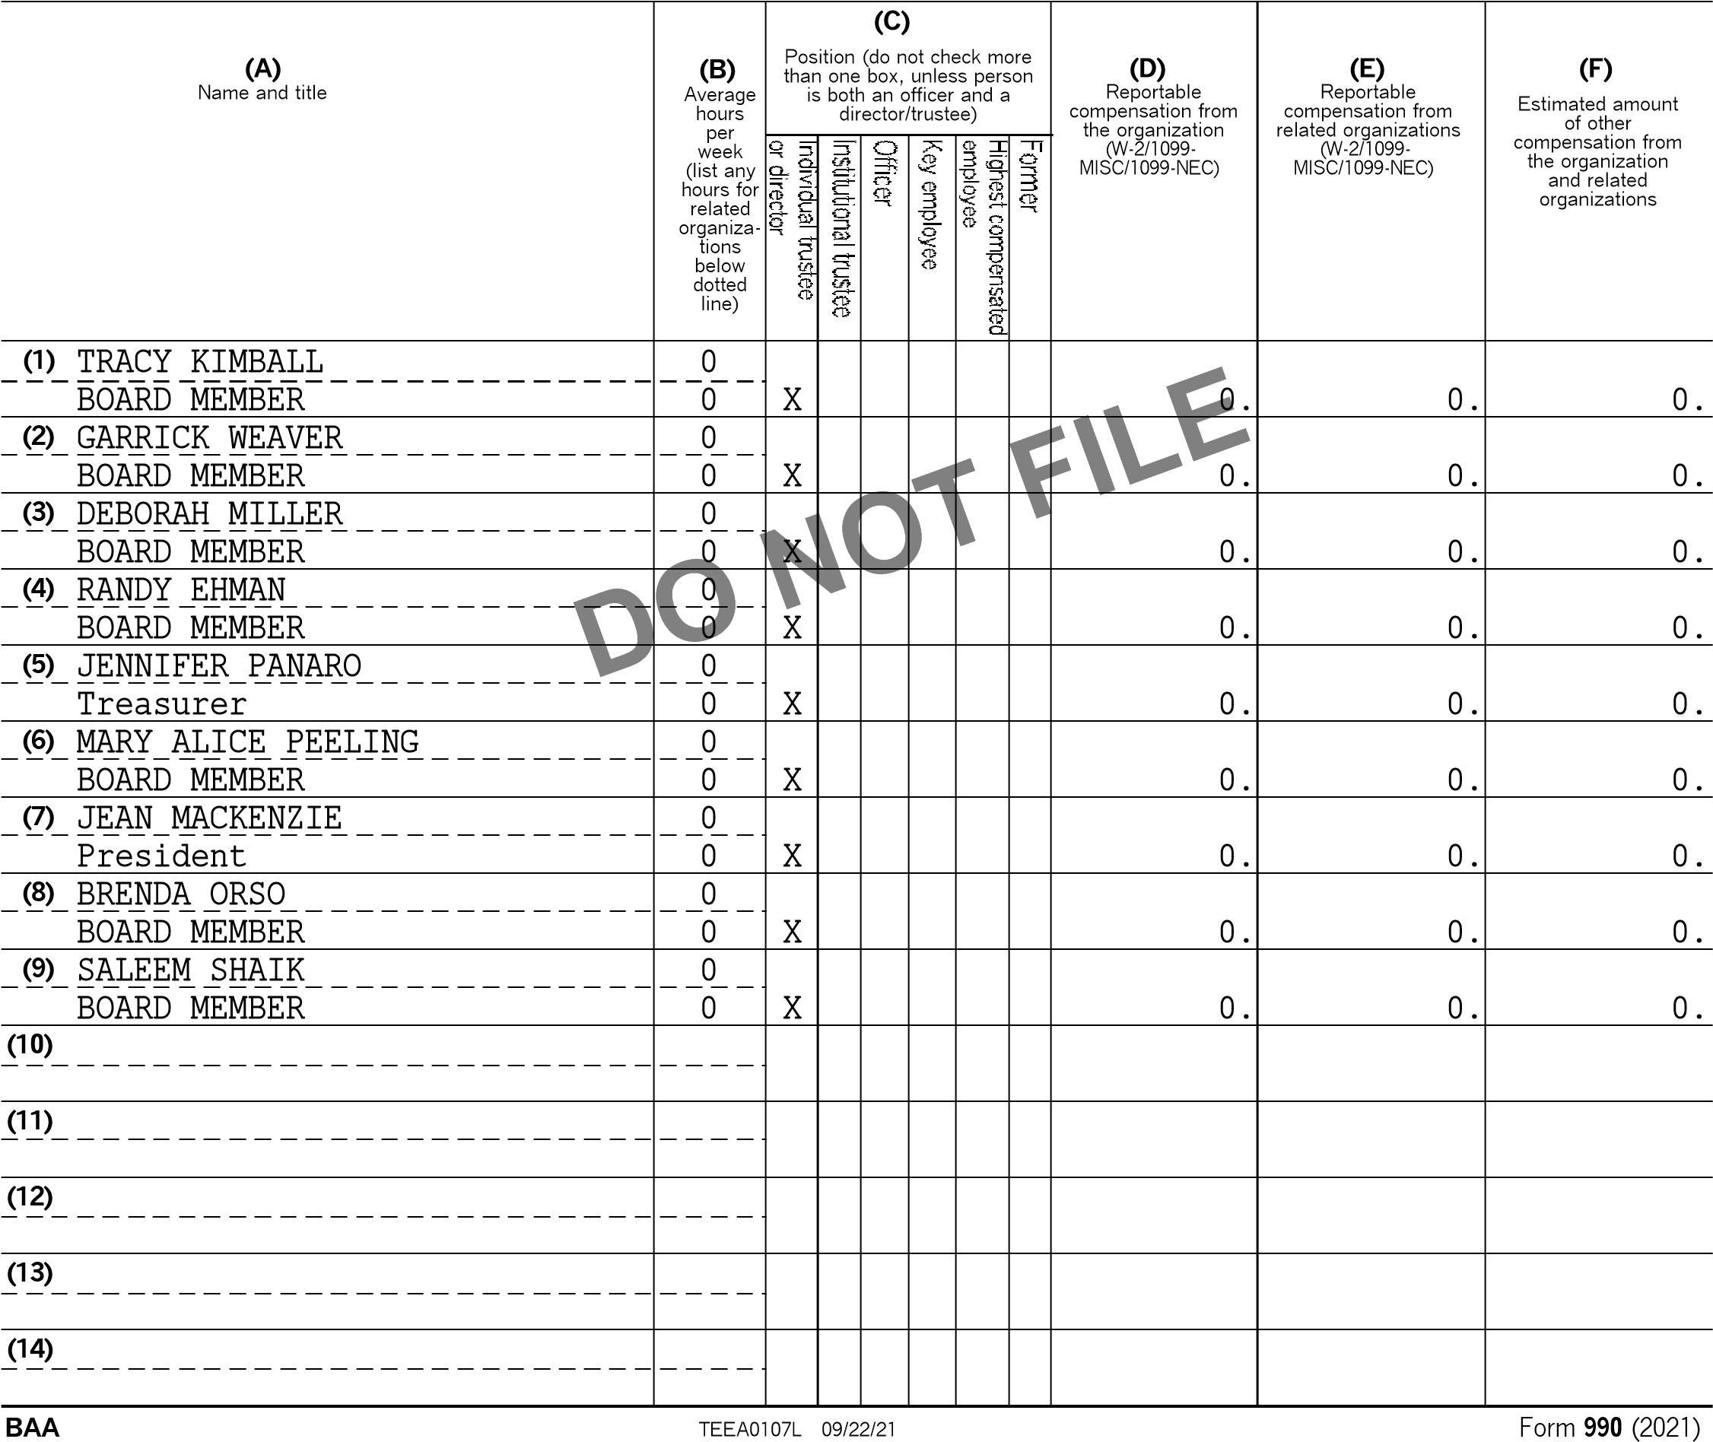

RACHEL KOHL COMMUNITY LIBRARY, INC 23-2127296

# Part VII Section A. Officers, Directors, Trustees, Key Employees, and Highest Compensated Employees *(continued)*

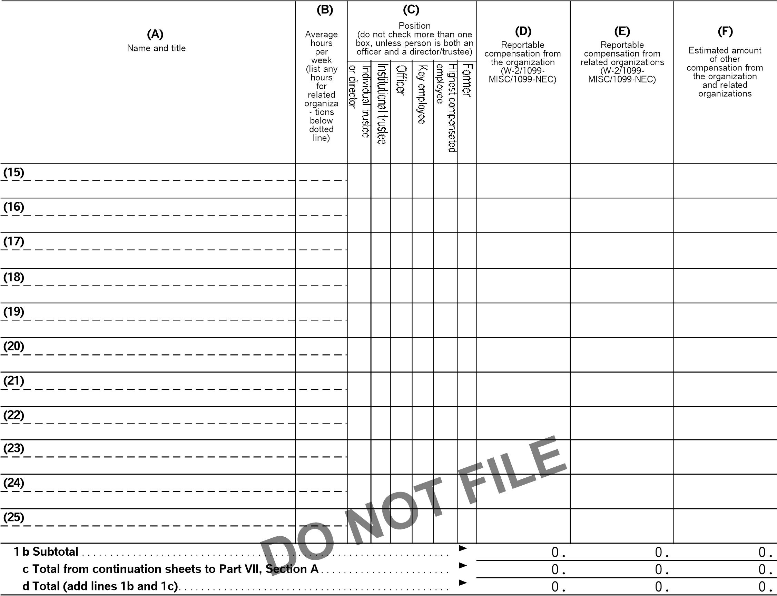

**2** Total number of individuals (including but not limited to those listed above) who received more than $100,000 of reportable compensation from the organization G 0

|  |  |  |  |  |
| --- | --- | --- | --- | --- |
| **3**  **4**  **5** | Did the organization list any **former** officer, director, trustee, key employee, or highest compensated employee  on line 1a? *If 'Yes,' complete Schedule J for such individual*. . . . . . . . . . . . . . . . . . . . . . . . . . . . . . . . . . . . . . . . . . . . . . . . . . . . . . . . .  For any individual listed on line 1a, is the sum of reportable compensation and other compensation from the organization and related organizations greater than $150,000? *If 'Yes,' complete Schedule J for such individual*. . . . . . . . . . . . . . . . . . . . . . . . . . . . . . . . . . . . . . . . . . . . . . . . . . . . . . . . . . . . . . . . . . . . . . . . . . . . . . . . . . . . . . . . . . . . . . . . . . . .  Did any person listed on line 1a receive or accrue compensation from any unrelated organization or individual  for services rendered to the organization? *If 'Yes,' complete Schedule J for such person*. . . . . . . . . . . . . . . . . . . . . . . . . . . . . . . |  | **Yes** | **No** |
|  |  |  |
| **3** |  | X |
|  |  |  |
| **4** |  | X |
|  |  |  |
| **5** |  | X |

# Section B. Independent Contractors

**1** Complete this table for your five highest compensated independent contractors that received more than $100,000 of compensation from the organization. Report compensation for the calendar year ending with or within the organization's tax year.

|  |  |  |  |
| --- | --- | --- | --- |
|  | **(A)** | **(B)** | **(C)** |
|  | Name and business address | Description of services | Compensation |
|  |  |  |  |
|  |  |  |  |
|  |  |  |  |
|  |  |  |  |
|  |  |  |  |
| **2** | Total number of independent contractors (including but not limited to those listed above) who received more than $100,000 of compensation from the organizationG 0 | |  |

**BAA** TEEA0108L 09/22/21 Form **990** (2021)

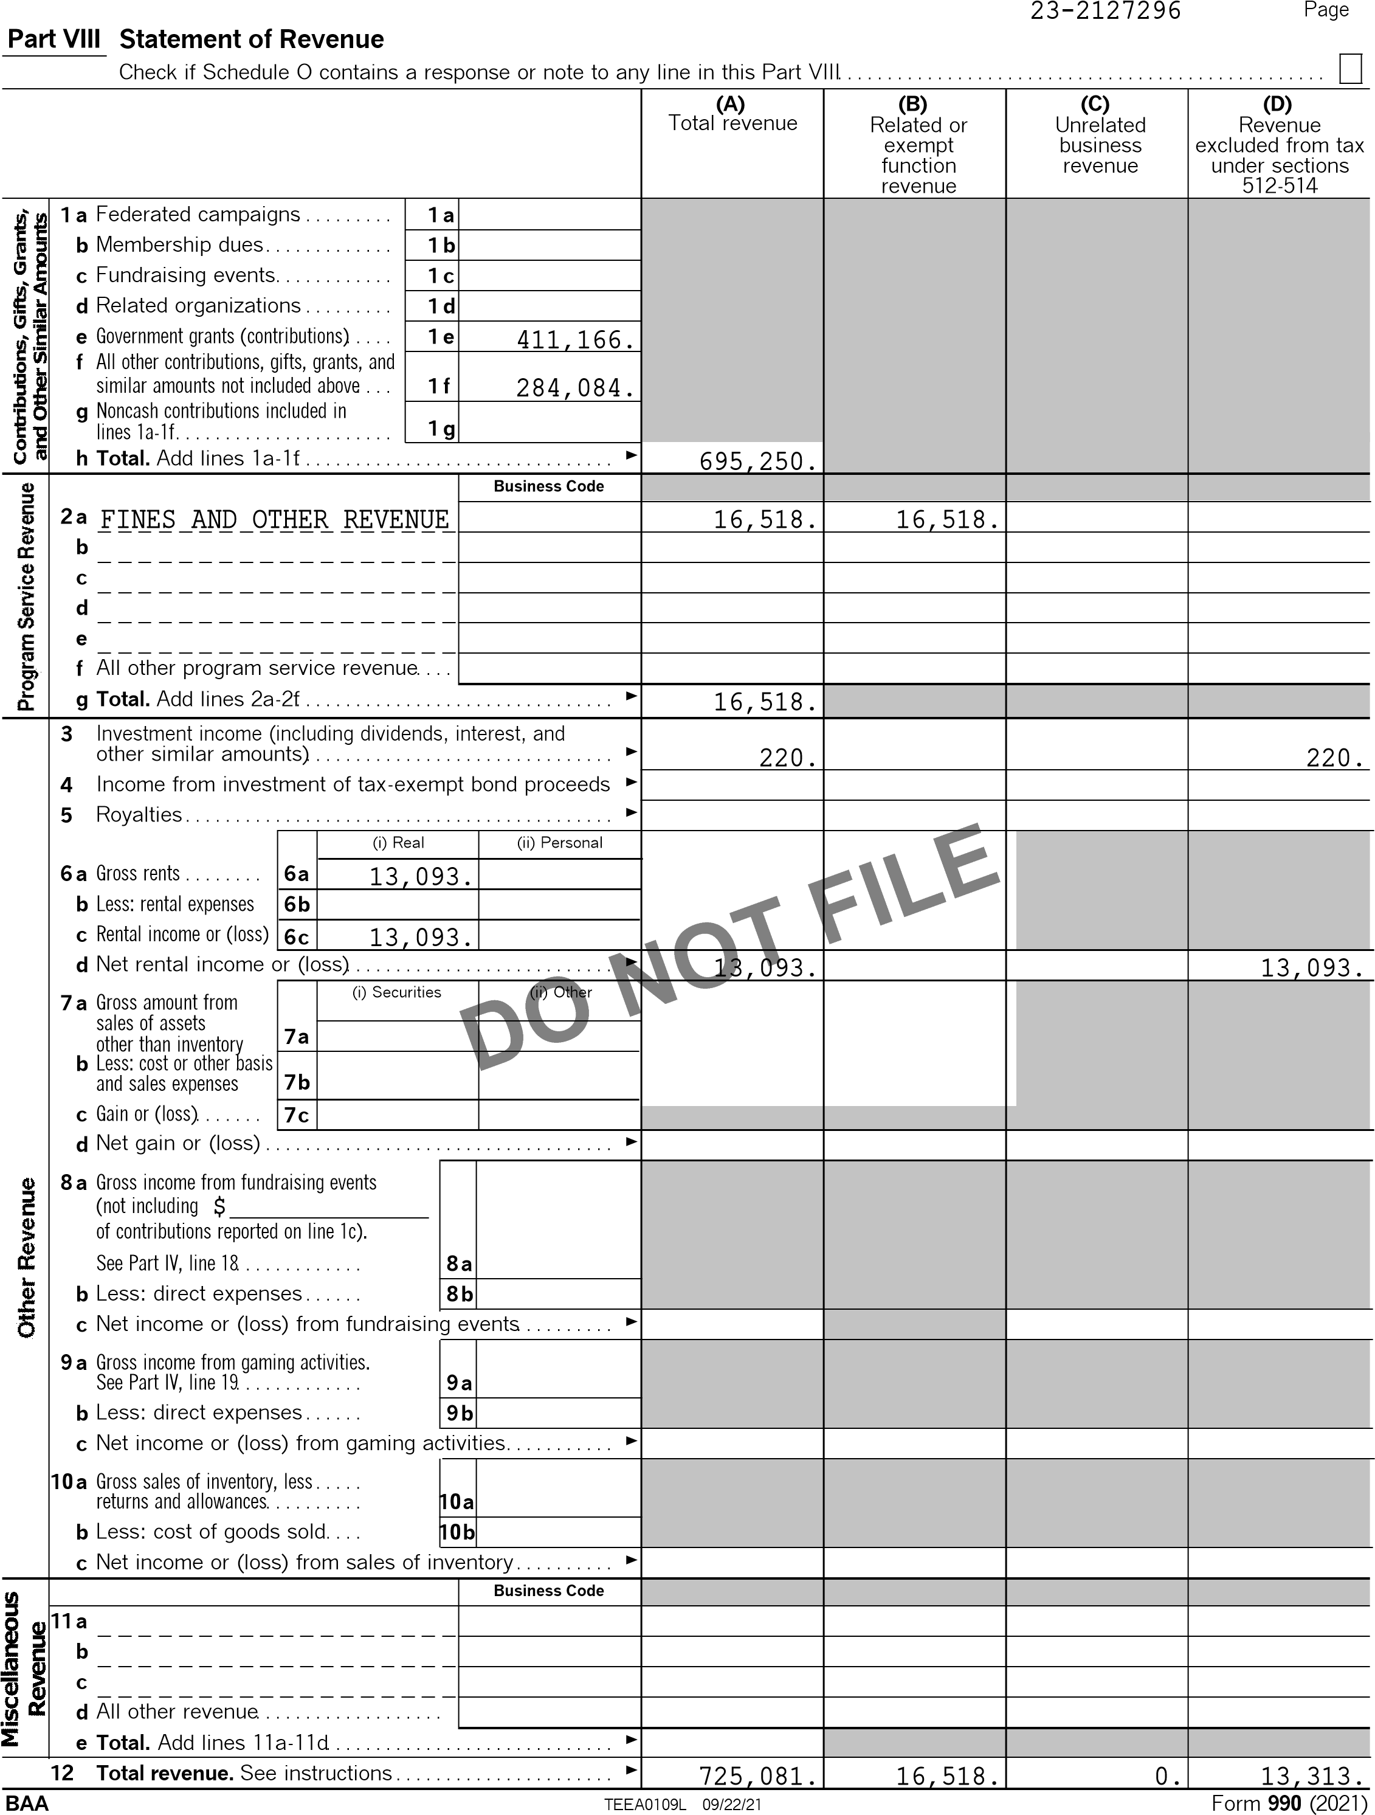

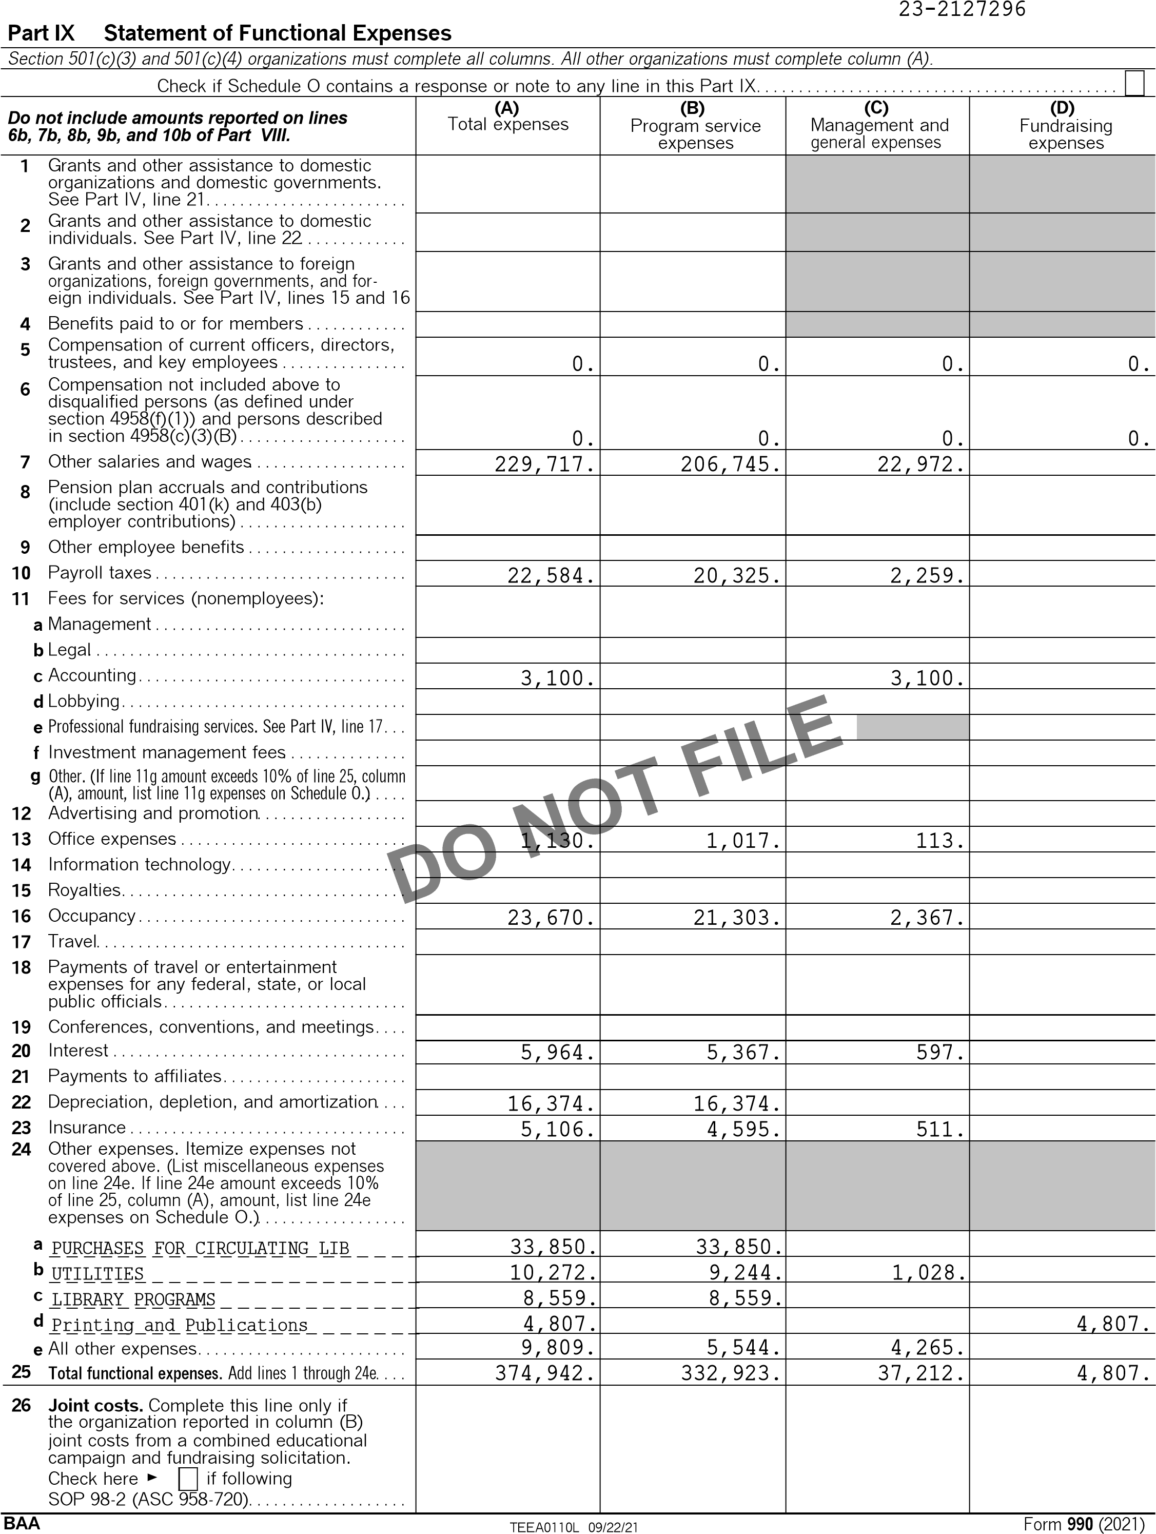

Form 990 (2021) 23-2127296 Page

|  |
| --- |
| **Part X** |

# Balance Sheet

Check if Schedule O contains a response or note to any line in this Part X . . . . . . . . . . . . . . . . . . . . . . . . . . . . . . . . . . . . . . . . . . . . . . . . . .

**(A) (B)**

Beginning of year End of year

1. Cash ' non-interest-bearing. . . . . . . . . . . . . . . . . . . . . . . . . . . . . . . . . . . . . . . . . . . . . . . . . . 343,076. **1** 643,795.
2. Savings and temporary cash investments. . . . . . . . . . . . . . . . . . . . . . . . . . . . . . . . . . . . . . **2**
3. Pledges and grants receivable, net. . . . . . . . . . . . . . . . . . . . . . . . . . . . . . . . . . . . . . . . . . . . **3**
4. Accounts receivable, net. . . . . . . . . . . . . . . . . . . . . . . . . . . . . . . . . . . . . . . . . . . . . . . . . . . . . . **4**
5. Loans and other receivables from any current or former officer, director, trustee, key employee, creator or founder, substantial contributor, or 35% controlled entity or family member of any of these persons . . . . . . . . . . . . . . . . . . . . . **5**
6. Loans and other receivables from other disqualified persons (as defined under section 4958(f)(1)), and persons described in section 4958(c)(3)(B). . . . . . . . . . . . . . **6**
7. Notes and loans receivable, net. . . . . . . . . . . . . . . . . . . . . . . . . . . . . . . . . . . . . . . . . . . . . . . **7**
8. Inventories for sale or use. . . . . . . . . . . . . . . . . . . . . . . . . . . . . . . . . . . . . . . . . . . . . . . . . . . . **8**
9. Prepaid expenses and deferred charges. . . . . . . . . . . . . . . . . . . . . . . . . . . . . . . . . . . . . . . **9**

**10a** Land, buildings, and equipment: cost or other basis.

Complete Part VI of Schedule D. . . . . . . . . . . . . . . . . . . . **10a** 572,527. **b** Less: accumulated depreciation. . . . . . . . . . . . . . . . . . . . **10b** 121,143. 463,168. **10c** 451,384.

1. Investments ' publicly traded securities. . . . . . . . . . . . . . . . . . . . . . . . . . . . . . . . . . . . . . . **11**
2. Investments ' other securities. See Part IV, line 11. . . . . . . . . . . . . . . . . . . . . . . . . . . . **12**
3. Investments ' program-related. See Part IV, line 11. . . . . . . . . . . . . . . . . . . . . . . . . . . **13**
4. Intangible assets. . . . . . . . . . . . . . . . . . . . . . . . . . . . . . . . . . . . . . . . . . . . . . . . . . . . . . . . . . . . . **14**
5. Other assets. See Part IV, line 11. . . . . . . . . . . . . . . . . . . . . . . . . . . . . . . . . . . . . . . . . . . . . 3,088. **15** 265. **16 Total assets.** Add lines 1 through 15 (must equal line 33). . . . . . . . . . . . . . . . . . . . . . . 809,332. **16** 1,095,444.



1. Accounts payable and accrued expenses. . . . . . . . . . . . . . . . . . . . . . . . . . . . . . . . . . . . . . **17**
2. Grants payable. . . . . . . . . . . . . . . . . . . . . . . . . . . . . . . . . . . . . . . . . . . . . . . . . . . . . . . . . . . . . . . **18**
3. Deferred revenue. . . . . . . . . . . . . . . . . . . . . . . . . . . . . . . . . . . . . . . . . . . . . . . . . . . . . . . . . . . . . **19 20** Tax-exempt bond liabilities . . . . . . . . . . . . . . . . . . . . . . . . . . . . . . . . . . . . . . . . . . . . . . . . . . . **20**
4. Escrow or custodial account liability. Complete Part IV of Schedule D. . . . . . . . . . . **21**
5. Loans and other payables to any current or former officer, director, trustee, key employee, creator or founder, substantial contributor, or 35% controlled entity or family member of any of these persons . . . . . . . . . . . . . . . . . . . . . **22**
6. Secured mortgages and notes payable to unrelated third parties . . . . . . . . . . . . . . . . 241,955. **23** 176,407.
7. Unsecured notes and loans payable to unrelated third parties. . . . . . . . . . . . . . . . . . . **24**
8. Other liabilities (including federal income tax, payables to related third parties,

and other liabilities not included on lines 17-24). Complete Part X of Schedule D. **25** 1,521.

1. **Total liabilities.** Add lines 17 through 25. . . . . . . . . . . . . . . . . . . . . . . . . . . . . . . . . . . . . . . 241,955. **26** 177,928.

**Organizations that follow FASB ASC 958, check here** G X **and complete lines 27, 28, 32, and 33.**

1. Net assets without donor restrictions . . . . . . . . . . . . . . . . . . . . . . . . . . . . . . . . . . . . . . . . . . 567,377. **27** 917,516.
2. Net assets with donor restrictions. . . . . . . . . . . . . . . . . . . . . . . . . . . . . . . . . . . . . . . . . . . . . **28**

**Organizations that do not follow FASB ASC 958, check here** G **and complete lines 29 through 33.**

1. Capital stock or trust principal, or current funds. . . . . . . . . . . . . . . . . . . . . . . . . . . . . . . . **29**
2. Paid-in or capital surplus, or land, building, or equipment fund. . . . . . . . . . . . . . . . . . **30**
3. Retained earnings, endowment, accumulated income, or other funds. . . . . . . . . . . . **31**
4. Total net assets or fund balances. . . . . . . . . . . . . . . . . . . . . . . . . . . . . . . . . . . . . . . . . . . . . 567,377. **32** 917,516. **33** Total liabilities and net assets/fund balances. . . . . . . . . . . . . . . . . . . . . . . . . . . . . . . . . . . 809,332. **33** 1,095,444.

**BAA** TEEA0111L 09/22/21 Form **990** (2021)

Form 990 (2021) 23-2127296

# Part XI Reconciliation of Net Assets

Check if Schedule O contains a response or note to any line in this Part XI. . . . . . . . . . . . . . . . . . . . . . . . . . . . . . . . . . . . . . . . . . . . . . . . . .

1. Total revenue (must equal Part VIII, column (A), line 12). . . . . . . . . . . . . . . . . . . . . . . . . . . . . . . . . . . . . . . . . . . . . . . . . **1** 725,081.
2. Total expenses (must equal Part IX, column (A), line 25). . . . . . . . . . . . . . . . . . . . . . . . . . . . . . . . . . . . . . . . . . . . . . . . . **2** 374,942.
3. Revenue less expenses. Subtract line 2 from line 1 . . . . . . . . . . . . . . . . . . . . . . . . . . . . . . . . . . . . . . . . . . . . . . . . . . . . . . **3** 350,139. **4** Net assets or fund balances at beginning of year (must equal Part X, line 32, column (A)). . . . . . . . . . . . . . . . . . **4** 567,377.
4. Net unrealized gains (losses) on investments. . . . . . . . . . . . . . . . . . . . . . . . . . . . . . . . . . . . . . . . . . . . . . . . . . . . . . . . . . . . **5**
5. Donated services and use of facilities. . . . . . . . . . . . . . . . . . . . . . . . . . . . . . . . . . . . . . . . . . . . . . . . . . . . . . . . . . . . . . . . . . . **6**
6. Investment expenses. . . . . . . . . . . . . . . . . . . . . . . . . . . . . . . . . . . . . . . . . . . . . . . . . . . . . . . . . . . . . . . . . . . . . . . . . . . . . . . . . . . **7**
7. Prior period adjustments . . . . . . . . . . . . . . . . . . . . . . . . . . . . . . . . . . . . . . . . . . . . . . . . . . . . . . . . . . . . . . . . . . . . . . . . . . . . . . . **8**
8. Other changes in net assets or fund balances (explain on Schedule O). . . . . . . . . . . . . . . . . . . . . . . . . . . . . . . . . . . . **9** 0.
9. Net assets or fund balances at end of year. Combine lines 3 through 9 (must equal Part X, line 32, column (B)) . . . . . . . . . . . . . . . . . . . . . . . . . . . . . . . . . . . . . . . . . . . . . . . . . . . . . . . . . . . . . . . . . . . . . . . . . . . . . . . . . . . . . . . . . . . **10** 917,516.

# Part XII Financial Statements and Reporting

Check if Schedule O contains a response or note to any line in this Part XII. . . . . . . . . . . . . . . . . . . . . . . . . . . . . . . . . . . . . . . . . . . . . . . . .

**Yes No**

**1** Accounting method used to prepare the Form 990: X Cash Accrual Other

If the organization changed its method of accounting from a prior year or checked 'Other,' explain on Schedule O.

**2a** Were the organization's financial statements compiled or reviewed by an independent accountant? . . . . . . . . . . . . . . . . . . . . **2a** X

If 'Yes,' check a box below to indicate whether the financial statements for the year were compiled or reviewed on a separate basis, consolidated basis, or both:

Separate basis Consolidated basis Both consolidated and separate basis

1. Were the organization's financial statements audited by an independent accountant?. . . . . . . . . . . . . . . . . . . . . . . . . . . . . . . . . . **2b** X

If 'Yes,' check a box below to indicate whether the financial statements for the year were audited on a separate basis, consolidated basis, or both:

Separate basis Consolidated basis Both consolidated and separate basis

1. If 'Yes' to line 2a or 2b, does the organization have a committee that assumes responsibility for oversight of the audit, review, or compilation of its financial statements and selection of an independent accountant?. . . . . . . . . . . . . . . . . . . . . . . . . **2c**

If the organization changed either its oversight process or selection process during the tax year, explain on Schedule O.

**3a** As a result of a federal award, was the organization required to undergo an audit or audits as set forth in the Single

Audit Act and OMB Circular A-133?. . . . . . . . . . . . . . . . . . . . . . . . . . . . . . . . . . . . . . . . . . . . . . . . . . . . . . . . . . . . . . . . . . . . . . . . . . . . . . . . **3a** X **b** If 'Yes,' did the organization undergo the required audit or audits? If the organization did not undergo the required audit or audits, explain why on Schedule O and describe any steps taken to undergo such audits. . . . . . . . . . . . . . . . . . . . . . . . . . . . **3b**



**BAA** TEEA0112L 09/22/21 Form **990** (2021)

|  |  |  |  |  |
| --- | --- | --- | --- | --- |
| **SCHEDULE A**  **(Form 990)** | | **Public Charity Status and Public Support**  **Complete if the organization is a section 501(c)(3) organization or a section 4947(a)(1) nonexempt charitable trust.** G **Attach to Form 990 or Form 990-EZ.** | | OMB No. 1545-0047 |
| **2021** |
| **Open to Public** |
| Department of the Treasury Internal Revenue Service | | G **Go to *www.irs.gov/Form990* for instructions and the latest information.** | | **Inspection** |
| **Name of the organization** | | | **Employer identification number** | |
| RACHEL KOHL COMMUNITY LIBRARY, INC | | | 23-2127296 | |
| **Part I** | **Reason for Public Charity Status.** (All organizations must complete this part.) See instructions. | | | |

The organization is not a private foundation because it is: (For lines 1 through 12, check only one box.) **1**A church, convention of churches, or association of churches described in **section 170(b)(1)(A)(i).**

**2**A school described in **section 170(b)(1)(A)(ii).** (Attach Schedule E (Form 990).)

**3**A hospital or a cooperative hospital service organization described in **section 170(b)(1)(A)(iii).**

**4**A medical research organization operated in conjunction with a hospital described in **section 170(b)(1)(A)(iii)**. Enter the hospital's name, city, and state:

**5**An organization operated for the benefit of a college or university owned or operated by a governmental unit described in **section 170(b)(1)(A)(iv).** (Complete Part II.)

**6**A federal, state, or local government or governmental unit described in **section 170(b)(1)(A)(v).**

**7** X An organization that normally receives a substantial part of its support from a governmental unit or from the general public described in **section 170(b)(1)(A)(vi).** (Complete Part II.)

**8**A community trust described in **section 170(b)(1)(A)(vi).** (Complete Part II.)

**9**An agricultural research organization described in **section 170(b)(1)(A)(ix)** operated in conjunction with a land-grant college or university or a non-land-grant college of agriculture (see instructions). Enter the name, city, and state of the college or university:

**10**An organization that normally receives (1) more than 33-1/3% of its support from contributions, membership fees, and gross receipts

from activities related to its exempt functions, subject to certain exceptions; and (2) no more than 33-1/3% of its support from gross investment income and unrelated business taxable income (less section 511 tax) from businesses acquired by the organization after June 30, 1975. See **section 509(a)(2).** (Complete Part III.)

**11**An organization organized and operated exclusively to test for public safety. See **section 509(a)(4).**

**12**An organization organized and operated exclusively for the benefit of, to perform the functions of, or to carry out the purposes of one or more publicly supported organizations described in **section 509(a)(1)** or **section 509(a)(2).** See **section 509(a)(3).** Check the box on lines 12a through 12d that describes the type of supporting organization and complete lines 12e, 12f, and 12g.

**aType I.** A supporting organization operated, supervised, or controlled by its supported organization(s), typically by giving the supported organization(s) the power to regularly appoint or elect a majority of the directors or trustees of the supporting organization. **You must complete Part IV, Sections A and B.**

**bType II.** A supporting organization supervised or controlled in connection with its supported organization(s), by having control or management of the supporting organization vested in the same persons that control or manage the supported organization(s). **You must complete Part IV, Sections A and C.**

**cType III functionally integrated.** A supporting organization operated in connection with, and functionally integrated with, its supported organization(s) (see instructions). **You must complete Part IV, Sections A, D, and E.**

**dType III non-functionally integrated.** A supporting organization operated in connection with its supported organization(s) that is not functionally integrated. The organization generally must satisfy a distribution requirement and an attentiveness requirement (see instructions). **You must complete Part IV, Sections A and D, and Part V. e**Check this box if the organization received a written determination from the IRS that it is a Type I, Type II, Type III functionally integrated, or Type III non-functionally integrated supporting organization.

**f** Enter the number of supported organizations. . . . . . . . . . . . . . . . . . . . . . . . . . . . . . . . . . . . . . . . . . . . . . . . . . . . . . . . . . . . . . . . . . . . . . . . . **g** Provide the following information about the supported organization(s).

|  |  |  |  |  |  |  |
| --- | --- | --- | --- | --- | --- | --- |
| **(i)** Name of supported organization | **(ii)** EIN | **(iii)** Type of organization | **(iv)** Is the | | **(v)** Amount of monetary | **(vi)** Amount of other |
|  |  | (described on lines 1-10 | organization listed | | support (see instructions) | support (see instructions) |
|  |  | above (see instructions)) | in your governing document? | |  |  |
| **Yes** | **No** |
| **(A)** |  |  |  |  |  |  |
| **(B)** |  |  |  |  |  |  |
| **(C)** |  |  |  |  |  |  |
| **(D)** |  |  |  |  |  |  |
| **(E)** |  |  |  |  |  |  |
| **Total** |  |  |  |  |  |  |

**BAA For Paperwork Reduction Act Notice, see the Instructions for Form 990 or 990-EZ. Schedule A (Form 990) 2021**

TEEA0401L 08/31/21

RACHEL KOHL COMMUNITY LIBRARY, INC 23-2127296

|  |  |
| --- | --- |
| **Part II** | **Support Schedule for Organizations Described in Sections 170(b)(1)(A)(iv) and 170(b)(1)(A)(vi)**  (Complete only if you checked the box on line 5, 7, or 8 of Part I or if the organization failed to qualify under Part III. If the organization fails to qualify under the tests listed below, please complete Part III.) |
|  |

# Section A. Public Support

|  |  |  |  |  |  |  |
| --- | --- | --- | --- | --- | --- | --- |
| **Calendar year (or fiscal year beginning in)** G   1. Gifts, grants, contributions, and membership fees received. (Do not include any 'unusual grants.'). . . . . . . . 2. Tax revenues levied for the organization's benefit and either paid to or expended on its behalf. . . . . . . . . . . . . . . . . . 3. The value of services or facilities furnished by a governmental unit to the organization without charge. . . . **4 Total.** Add lines 1 through 3. . . 4. The portion of total contributions by each person (other than a governmental unit or publicly supported organization) included on line 1 that exceeds 2% of the amount shown on line 11, column (f). . . 5. **Public support.** Subtract line 5   from line 4 . . . . . . . . . . . . . . . . . . . | **(a)** 2017 | **(b)** 2018 | **(c)** 2019 | **(d)** 2020 | **(e)** 2021 | **(f)** Total |
| 381,561. | 478,731. | 441,703. | 494,290. | 636,107. | 2,432,392. |
|  |  |  |  |  | 0. |
| 13,153. | 14,524. | 13,116. | 6,933. | 9,281. | 57,007. |
| 394,714. | 493,255. | 454,819. | 501,223. | 645,388. | 2,489,399. |
|  |  |  |  |  | 0. |
|  |  |  |  |  | 2,489,399. |

# Section B. Total Support

|  |  |  |  |  |  |  |  |
| --- | --- | --- | --- | --- | --- | --- | --- |
| **Calendar year (or fiscal year beginning in)** G   1. Amounts from line 4 . . . . . . . . . . 2. Gross income from interest, dividends, payments received on securities loans, rents, royalties, and income from similar sources . . . . . . . . . . . . . . . 3. Net income from unrelated business activities, whether or not the business is regularly carried on. . . . . . . . . . . . . . . . . . . . 4. Other income. Do not include gain or loss from the sale of capital assets (Explain in   Part VI.). . . . . . . . . . . . . . . . . . . . . .   1. **Total support.** Add lines 7   through 10. . . . . . . . . . . . . . . . . . . .   1. Gross receipts from related activities, etc. (see instructions) | **(a)** 2017 | **(b)** 2018 | **(c)** 2019 | **(d)** 2020 | **(e)** 2021 | | **(f)** Total |
| 394,714. | 493,255. | 454,819. | 501,223. | 645,388. | | 2,489,399. |
| 37. | 53. |  |  |  | | 90. |
|  |  |  |  |  | | 0. |
|  |  |  |  |  | | 0. |
|  |  |  |  |  | | 2,489,489. |
| . . . . . . . . . . . . . . . . . . . . . . . . . . . . . . . . . . . . . . . . . . . . . . . . . . | | | | | **12** | 0. |

**13 First 5 years.** If the Form 990 is for the organization's first, second, third, fourth, or fifth tax year as a section 501(c)(3)

organization, check this box and **stop here**. . . . . . . . . . . . . . . . . . . . . . . . . . . . . . . . . . . . . . . . . . . . . . . . . . . . . . . . . . . . . . . . . . . . . . . . . . . . . . . . . . . . G

|  |  |  |
| --- | --- | --- |
| **Section C. Computation of Public Support Percentage** | |  |
| **14** Public support percentage for 2021 (line 6, column (f), divided by line 11, column (f)). . . . . . . . . . . . . . . . . . . . . . . . . . **15** Public support percentage from 2020 Schedule A, Part II, line 14 . . . . . . . . . . . . . . . . . . . . . . . . . . . . . . . . . . . . . . . . . . . . . | **14** | 100.00 % |
| **15** | 99.99 % |

**16a 33-1/3% support test**'**2021.** If the organization did not check the box on line 13, and line 14 is 33-1/3% or more, check this box

and **stop here.** The organization qualifies as a publicly supported organization. . . . . . . . . . . . . . . . . . . . . . . . . . . . . . . . . . . . . . . . . . . . . . . . . . . G X

**b 33-1/3% support test**'**2020.** If the organization did not check a box on line 13 or 16a, and line 15 is 33-1/3% or more, check this box

and **stop here.** The organization qualifies as a publicly supported organization. . . . . . . . . . . . . . . . . . . . . . . . . . . . . . . . . . . . . . . . . . . . . . . . . . . G

**17a 10%-facts-and-circumstances test**'**2021.** If the organization did not check a box on line 13, 16a, or 16b, and line 14 is 10% or more, and if the organization meets the facts-and-circumstances test, check this box and **stop here.** Explain in Part VI how the organization meets the facts-and-circumstances test. The organization qualifies as a publicly supported organization. . . . . . . . . . . G

**b 10%-facts-and-circumstances test**'**2020.** If the organization did not check a box on line 13, 16a, 16b, or 17a, and line 15 is 10% or more, and if the organization meets the facts-and-circumstances test, check this box and **stop here.** Explain in Part VI how the organization meets the facts-and-circumstances test. The organization qualifies as a publicly supported organization. . . . . . . . . . . . . . . G

**18 Private foundation.** If the organization did not check a box on line 13, 16a, 16b, 17a, or 17b, check this box and see instructions. . . G

**BAA Schedule A (Form 990) 2021**

TEEA0402L 08/31/21

RACHEL KOHL COMMUNITY LIBRARY, INC 23-2127296

|  |  |
| --- | --- |
| **Part III** | **Support Schedule for Organizations Described in Section 509(a)(2)**  (Complete only if you checked the box on line 10 of Part I or if the organization failed to qualify under Part II. If the organization fails to qualify under the tests listed below, please complete Part II.) |
|  |

|  |  |  |  |  |  |  |
| --- | --- | --- | --- | --- | --- | --- |
| **Calendar year (or fiscal year beginning in)** G   1. Gifts, grants, contributions, and membership fees received. (Do not include any 'unusual grants.'). . . . . . . . . 2. Gross receipts from admissions, merchandise sold or services performed, or facilities furnished in any activity that is related to the organization's tax-exempt purpose. . . . . . . . . . . 3. Gross receipts from activities that are not an unrelated trade or business under section 513. 4. Tax revenues levied for the organization's benefit and   either paid to or expended on its behalf. . . . . . . . . . . . . . . . . . . . .   1. The value of services or facilities furnished by a governmental unit to the organization without charge. . . . 2. **Total.** Add lines 1 through 5 . . .   **7a** Amounts included on lines 1,  2, and 3 received from  disqualified persons. . . . . . . . . . .  **b** Amounts included on lines 2 and 3 received from other than disqualified persons that exceed the greater of $5,000 or  1% of the amount on line 13  for the year. . . . . . . . . . . . . . . . . . . **c** Add lines 7a and 7b. . . . . . . . . . .  **Public support.** (Subtract line  7c from line 6.). . . . . . . . . . . . . . . | **(a)** 2017 | **(b)** 2018 | **(c)** 2019 | **(d)** 2020 | **(e)** 2021 | **(f)** Total |
|  |  |  |  |  |  |
|  |  |  |  |  |  |
|  |  |  |  |  |  |
|  |  |  |  |  |  |
|  |  |  |  |  |  |
|  |  |  |  |  |  |
|  |  |  |  |  |  |
|  |  |  |  |  |  |
|  |  |  |  |  |  |
|  |  |  |  |  |  |

# Section A. Public Support



**Section B. Total Support**

**a)**

**(**

2017

**b)**

**(**

2018

**(**

**c)**

2019

**d)**

**(**

2020

**(**

**e)**

2021

**(**

**f)**

Total

**dar year (or fiscal year beginning in)**

**Calen**

G

Amounts from line 6

. . . . . . . . . .

**9**

Gross income from interest, dividends,

**a**

**10**

payments received on securities loans,

rents, royalties, and income from

similar sources

. . . . . . . . . . . . . . . . . .

Unrelated business taxable

**b**

income (less section 511

taxes) from businesses

acquired after June 30, 1975

. . .

Add lines 10a and 10b

. . . . . . . . .

**c**

Net income from unrelated business

**11**

activities not included on line 10b,

whether or not the business is

regularly carried on

. . . . . . . . . . . . . . .

Other income. Do not include

**12**

gain or loss from the sale of

capital assets (Explain in

Part VI.)

. . . . . . . . . . . . . . . . . . . . . .

**13**

**Total support.**

(

Add Iines 9,

10

c, 11, and

12.)

. . . . . . . . . . . . . .

**14**

**First 5 years.**

If the Form 990 is for the organization's first, second, third, fourth, or fifth tax year as a section 501(c)(3)

G

organization, check this box and

**stop here**

. . . . . . . . . . . . . . . . . . . . . . . . . . . . . . . . . . . . . . . . . . . . . . . . . . . . . . . . . . . . . . . . . . . . . . . . . . . . . . . . . . . .

|  |  |  |
| --- | --- | --- |
| **Section C. Computation of Public Support Percentage** | |  |
| **15** Public support percentage for 2021 (line 8, column (f), divided by line 13, column (f)). . . . . . . . . . . . . . . . . . . . . . . . . . **16** Public support percentage from 2020 Schedule A, Part III, line 15. . . . . . . . . . . . . . . . . . . . . . . . . . . . . . . . . . . . . . . . . . . . . | **15** | % |
| **16** | % |
| **Section D. Computation of Investment Income Percentage** | |  |
| **17** Investment income percentage for **2021** (line 10c, column (f), divided by line 13, column (f)). . . . . . . . . . . . . . . . . . . . **18** Investment income percentage from **2020** Schedule A, Part III, line 17 . . . . . . . . . . . . . . . . . . . . . . . . . . . . . . . . . . . . . . . . | **17** | % |
| **18** | % |

**19a 33-1/3% support tests**'**2021.** If the organization did not check the box on line 14, and line 15 is more than 33-1/3%, and line 17 is not more than 33-1/3%, check this box and **stop here.** The organization qualifies as a publicly supported organization . . . . . . . . . . . G

**b 33-1/3% support tests**'**2020.** If the organization did not check a box on line 14 or line 19a, and line 16 is more than 33-1/3%, and line 18 is not more than 33-1/3%, check this box and **stop here.** The organization qualifies as a publicly supported organization. . . . . G

**20 Private foundation.** If the organization did not check a box on line 14, 19a, or 19b, check this box and see instructions. . . . . . . . . . . . . G

**BAA** TEEA0403L 08/31/21 **Schedule A (Form 990) 2021**

**Part IV**

**Supporting Organizations**

(Complete only if you checked a box in line 12 on Part I. If you checked box 12a, Part I, complete Sections A and B. If you checked box 12b, Part I, complete Sections A and C. If you checked box 12c, Part I, complete Sections A, D, and E. If you checked box 12d, Part I, complete Sections A and D, and complete Part V.)

# Section A. All Supporting Organizations

|  |  |  |  |
| --- | --- | --- | --- |
|  | | **Yes** | **No** |
| 1. Are all of the organization's supported organizations listed by name in the organization's governing documents? *If 'No,' describe in* ***Part VI*** *how the supported organizations are designated. If designated by class or purpose, describe the designation. If historic and continuing relationship, explain.* 2. Did the organization have any supported organization that does not have an IRS determination of status under section 509(a)(1) or (2)? *If 'Yes,' explain in* ***Part VI*** *how the organization determined that the supported organization was described in section 509(a)(1) or (2)*.   **3a** Did the organization have a supported organization described in section 501(c)(4), (5), or (6)? *If 'Yes,' answer lines 3b and 3c below.*   1. Did the organization confirm that each supported organization qualified under section 501(c)(4), (5), or (6) and satisfied the public support tests under section 509(a)(2)? *If 'Yes,' describe in* ***Part VI*** *when and how the organization made the determination*. 2. Did the organization ensure that all support to such organizations was used exclusively for section 170(c)(2)(B) purposes? *If 'Yes,' explain in* ***Part VI*** *what controls the organization put in place to ensure such use.*   **4a** Was any supported organization not organized in the United States ('foreign supported organization')? *If 'Yes' and if you checked box 12a or 12b in Part I, answer lines 4b and 4c below.*   1. Did the organization have ultimate control and discretion in deciding whether to make grants to the foreign supported organization? *If 'Yes,' describe in* ***Part VI*** *how the organization had such control and discretion despite being controlled or supervised by or in connection with its supported organizations*. 2. Did the organization support any foreign supported organization that does not have an IRS determination under sections 501(c)(3) and 509(a)(1) or (2)? *If 'Yes,' explain in* ***Part VI*** *what controls the organization used to ensure that all support to the foreign supported organization was used exclusively for section 170(c)(2)(B) purposes.*   **5a** Did the organization add, substitute, or remove any supported organizations during the tax year? *If 'Yes,' answer lines 5b and 5c below (if applicable). Also, provide detail in* ***Part VI,*** *including (i) the names and EIN numbers of the supported organizations added, substituted, or removed; (ii) the reasons for each such action; (iii) the authority under the organization's organizing document authorizing such action; and (iv) how the action was accomplished (such as by amendment to the organizing document)*.   1. **Type I or Type II only.** Was any added or substituted supported organization part of a class already designated in the organization's organizing document? 2. **Substitutions only.** Was the substitution the result of an event beyond the organization's control? 3. Did the organization provide support (whether in the form of grants or the provision of services or facilities) to anyone other than (i) its supported organizations, (ii) individuals that are part of the charitable class benefited by one or more of its supported organizations, or (iii) other supporting organizations that also support or benefit one or more of the filing organization's supported organizations? *If 'Yes,' provide detail in* ***Part VI.*** 4. Did the organization provide a grant, loan, compensation, or other similar payment to a substantial contributor (as defined in section 4958(c)(3)(C)), a family member of a substantial contributor, or a 35% controlled entity with regard to a substantial contributor? *If 'Yes,' complete Part I of Schedule L (Form 990)*. 5. Did the organization make a loan to a disqualified person (as defined in section 4958) not described on line 7? *If 'Yes,' complete Part I of Schedule L (Form 990).*   **9a** Was the organization controlled directly or indirectly at any time during the tax year by one or more disqualified persons, as defined in section 4946 (other than foundation managers and organizations described in section 509(a)(1) or (2))? *If 'Yes,' provide detail in* ***Part VI.***   1. Did one or more disqualified persons (as defined on line 9a) hold a controlling interest in any entity in which the supporting organization had an interest? *If 'Yes,' provide detail in* ***Part VI.*** 2. Did a disqualified person (as defined on line 9a) have an ownership interest in, or derive any personal benefit from, assets in which the supporting organization also had an interest? *If 'Yes,' provide detail in* ***Part VI.***   **10a** Was the organization subject to the excess business holdings rules of section 4943 because of section 4943(f) (regarding certain Type II supporting organizations, and all Type III non-functionally integrated supporting organizations)? *If 'Yes,' answer line 10b below.*  **b** Did the organization have any excess business holdings in the tax year? *(Use Schedule C, Form 4720, to determine whether the organization had excess business holdings.)* |  |  |  |
| **1** |  |  |
|  |  |  |
| **2** |  |  |
|  |  |  |
| **3a** |  |  |
|  |  |  |
| **3b** |  |  |
|  |  |  |
| **3c** |  |  |
|  |  |  |
| **4a** |  |  |
|  |  |  |
| **4b** |  |  |
|  |  |  |
| **4c** |  |  |
|  |  |  |
| **5a** |  |  |
|  |  |  |
| **5b** |  |  |
| **5c** |  |  |
|  |  |  |
| **6** |  |  |
|  |  |  |
| **7** |  |  |
|  |  |  |
| **8** |  |  |
|  |  |  |
| **9a** |  |  |
|  |  |  |
| **9b** |  |  |
|  |  |  |
| **9c** |  |  |
|  |  |  |
| **10a** |  |  |
|  |  |  |
| **10b** |  |  |

**BAA** TEEA0404L 08/31/21 **Schedule A (Form 990) 2021**

|  |  |  |  |  |
| --- | --- | --- | --- | --- |
| **Part IV** | **Supporting Organizations** *(continued)* |  | |  |
| **11** Has the organization accepted a gift or contribution from any of the following persons?   1. A person who directly or indirectly controls, either alone or together with persons described on lines 11b and 11c below, the governing body of a supported organization? 2. A family member of a person described on line 11a above? 3. A 35% controlled entity of a person described on line 11a or 11b above? *If 'Yes' to line 11a, 11b, or 11c, provide detail in* ***Part VI.*** | |  | **Yes** | **No** |
|  |  |  |
| **11a** |  |  |
| **11b** |  |  |
| **11c** |  |  |

# Section B. Type I Supporting Organizations

|  |  |  |  |  |
| --- | --- | --- | --- | --- |
| **1**  **2** | Did the governing body, members of the governing body, officers acting in their official capacity, or membership of one or more supported organizations have the power to regularly appoint or elect at least a majority of the organization's officers, directors, or trustees at all times during the tax year? *If 'No,' describe in* ***Part VI*** *how the supported organization(s) effectively operated, supervised, or controlled the organization's activities. If the organization had more than one supported organization, describe how the powers to appoint and/or remove officers, directors, or trustees were allocated among the supported organizations and what conditions or restrictions, if any, applied to such powers during the tax* year.  Did the organization operate for the benefit of any supported organization other than the supported organization(s) that operated, supervised, or controlled the supporting organization? *If 'Yes,' explain in* ***Part VI*** *how providing such benefit carried out the purposes of the supported organization(s) that operated, supervised, or controlled the supporting organization.* |  | **Yes** | **No** |
|  |  |  |
| **1** |  |  |
|  |  |  |
| **2** |  |  |

# Section C. Type II Supporting Organizations

|  |  |  |  |  |
| --- | --- | --- | --- | --- |
| **1** | Were a majority of the organization's directors or trustees during the tax year also a majority of the directors or trustees of each of the organization's supported organization(s)? *If 'No,' describe in* ***Part VI*** *how control or management of the supporting organization was vested in the same persons that controlled or managed the supported organization(s).* |  | **Yes** | **No** |
|  |  |  |
| **1** |  |  |

# Section D. All Type III Supporting Organizations

**Yes No**

1. Did the organization provide to each of its supported organizations, by the last day of the fifth month of the organization's tax year, (i) a written notice describing the type and amount of support provided during the prior tax year, (ii) a copy of the Form 990 that was most recently filed as of the date of notification, and (iii) copies of the organization's governing documents in effect on the date of notification, to the extent not previously provided? **1**



1. Were any of the organization's officers, directors, or trustees either (i) appointed or elected by the supported organization(s) or (ii) serving on the governing body of a supported organization? *If 'No,' explain in* ***Part VI*** *how the organization maintained a close and continuous working relationship with the supported organization(s).* **2**
2. By reason of the relationship described on line 2, above, did the organization's supported organizations have a significant voice in the organization's investment policies and in directing the use of the organization's income or assets at

all times during the tax year? *If 'Yes,' describe in* ***Part VI*** *the role the organization's supported organizations played*

*in this regard.* **3**

# Section E. Type III Functionally Integrated Supporting Organizations

**1** *Check the box next to the method that the organization used to satisfy the Integral Part Test during the year* ***(see instructions).***

1. The organization satisfied the Activities Test. *Complete* ***line 2*** *below.*
2. The organization is the parent of each of its supported organizations. *Complete* ***line 3*** *below.* **c**  The organization supported a governmental entity. *Describe in* ***Part VI*** *how you supported a governmental entity (see instructions).*

|  |  |  |  |
| --- | --- | --- | --- |
| **2** Activities Test. ***Answer lines 2a and 2b below.*** | | **Yes** | **No** |
| 1. Did substantially all of the organization's activities during the tax year directly further the exempt purposes of the supported organization(s) to which the organization was responsive? *If 'Yes,' then in* ***Part VI identify those supported organizations and explain*** *how these activities directly furthered their exempt purposes, how the organization was responsive to those supported organizations, and how the organization determined that these activities constituted substantially all of its activities.* 2. Did the activities described on line 2a, above, constitute activities that, but for the organization's involvement, one or more of the organization's supported organization(s) would have been engaged in? *If 'Yes,' explain in* ***Part VI*** *the reasons for the organization's position that its supported organization(s) would have engaged in these activities but for the organization's involvement.*   **3** Parent of Supported Organizations. ***Answer lines 3a and 3b below.***   1. Did the organization have the power to regularly appoint or elect a majority of the officers, directors, or trustees of each of the supported organizations? *If 'Yes' or 'No,' provide details in* ***Part VI.*** 2. Did the organization exercise a substantial degree of direction over the policies, programs, and activities of each of its supported organizations? *If 'Yes,' describe in* ***Part VI*** *the role played by the organization in this regard.* |  |  |  |
| **2a** |  |  |
|  |  |  |
| **2b** |  |  |
|  |  |  |
| **3a** |  |  |
|  |  |  |
| **3b** |  |  |

**BAA** TEEA0405L 08/31/21 **Schedule A (Form 990) 2021**

|  |  |
| --- | --- |
| **Part V** | **Type III Non-Functionally Integrated 509(a)(3) Supporting Organizations** |

**1**  Check here if the organization satisfied the Integral Part Test as a qualifying trust on Nov. 20, 1970 (explain in Part VI). **See instructions.** All other Type III non-functionally integrated supporting organizations must complete Sections A through E.

|  |  |  |  |  |  |
| --- | --- | --- | --- | --- | --- |
| **Section A** ' **Adjusted Net Income** | | | | (A) Prior Year | (B) Current Year (optional) |
| **1** Net short-term capital gain | | | **1** |  |  |
| **2** Recoveries of prior-year distributions | | | **2** |  |  |
| **3** Other gross income (see instructions) | | | **3** |  |  |
| **4** Add lines 1 through 3. | | | **4** |  |  |
| **5** Depreciation and depletion | | | **5** |  |  |
| **6** Portion of operating expenses paid or incurred for production or collection of gross income or for management, conservation, or maintenance of property held for production of income (see instructions) | | | **6** |  |  |
| **7** Other expenses (see instructions) | | | **7** |  |  |
| **8 Adjusted Net Income** (subtract lines 5, 6, and 7 from line 4) | | | **8** |  |  |
| **Section B** ' **Minimum Asset Amount** | | | | (A) Prior Year | (B) Current Year (optional) |
| **1** Aggregate fair market value of all non-exempt-use assets (see instructions for short tax year or assets held for part of year): | | |  |  |  |
| **a** Average monthly value of securities | | | **1a** |  |  |
| **b** Average monthly cash balances | | | **1b** |  |  |
| **c** Fair market value of other non-exempt-use assets | | | **1c** |  |  |
| **d Total** (add lines 1a, 1b, and 1c) | | | **1d** |  |  |
| **e Discount** claimed for blockage or other factors *(explain in detail in* ***Part VI****)*: | | |  |  |  |
| **2** Acquisition indebtedness applicable to non-exempt-use assets | | | **2** |  |  |
| **3** Subtract line 2 from line 1d. | | | **3** |  |  |
| **4** Cash deemed held for exempt use. Enter 0.015 of line 3 (for greater amount, see instructions). | | | **4** |  |  |
| **5** Net value of non-exempt-use assets (subtract line 4 from line 3) | | | **5** |  |  |
| **6** Multiply line 5 by 0.035. | | | **6** |  |  |
| **7** Recoveries of prior-year distributions | | | **7** |  |  |
| **8 Minimum Asset Amount** (add line 7 to line 6) | | | **8** |  |  |
| **Section C** ' **Distributable Amount** | | | |  | Current Year |
| **1** Adjusted net income for prior year (from Section A, line 8, column A) | | | **1** |  |  |
| **2** Enter 0.85 of line 1. | | | **2** |  |  |
| **3** Minimum asset amount for prior year (from Section B, line 8, column A) | | | **3** |  |  |
| **4** Enter greater of line 2 or line 3. | | | **4** |  |  |
| **5** Income tax imposed in prior year | | | **5** |  |  |
| **6 Distributable Amount.** Subtract line 5 from line 4, unless subject to emergency temporary reduction (see instructions). | | | **6** |  |  |
| **7** |  | Check here if the current year is the organization's first as a non-functionally integrated Type III supporting organization | | | |

(see instructions).

**BAA Schedule A (Form 990) 2021**

TEEA0406L 08/31/21

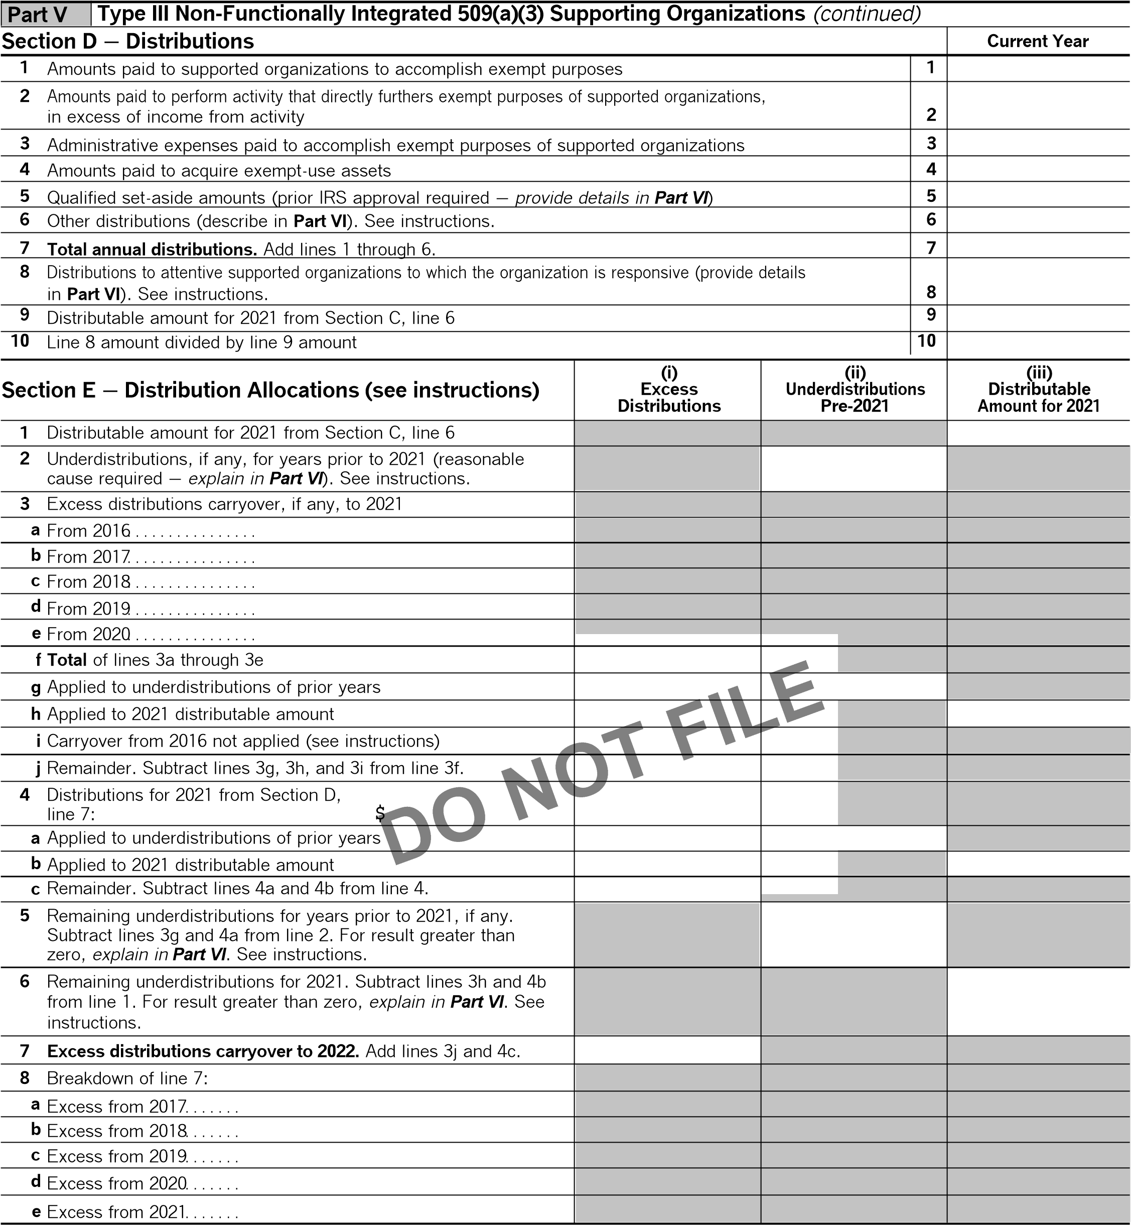

**BAA Schedule A (Form 990) 2021**

TEEA0407L 08/31/21

RACHEL KOHL COMMUNITY LIBRARY, INC 23-2127296

|  |  |
| --- | --- |
| **Part VI** | **Supplemental Information.** Provide the explanations required by Part II, line 10; Part II, line 17a or 17b; Part  III, line 12; Part IV, Section A, lines 1, 2, 3b, 3c, 4b, 4c, 5a, 6, 9a, 9b, 9c, 11a, 11b, and 11c; Part IV, Section  B, lines 1 and 2; Part IV, Section C, line 1; Part IV, Section D, lines 2 and 3; Part IV, Section E, lines 1c, 2a, 2b, 3a, and 3b; Part V, line 1; Part V, Section B, line 1e; Part V, Section D, lines 5, 6, and 8; and Part V, Section E, lines 2, 5, and 6. Also complete this part for any additional information. (See instructions.) |
|  |



**BAA** TEEA0408L 08/31/21 **Schedule A (Form 990) 2021**

|  |  |  |  |  |
| --- | --- | --- | --- | --- |
| **SCHEDULE D**  **(Form 990)**  Department of the Treasury  Internal Revenue Service | | **Supplemental Financial Statements**  G **Complete if the organization answered 'Yes' on Form 990, Part IV, line 6, 7, 8, 9, 10, 11a, 11b, 11c, 11d, 11e, 11f, 12a, or 12b.** G **Attach to Form 990.**  G **Go to *www.irs.gov/Form990* for instructions and the latest information.** | | OMB No. 1545-0047 |
| **2021** |
| **Open to Public Inspection** |
| **Name of the organization** | | | **Employer identification number** | |
| RACHEL KOHL COMMUNITY LIBRARY, INC | | | 23-2127296 | |
| **Part I** | **Organizations Maintaining Donor Advised Funds or Other Similar Funds or Accounts.** | | | |

Complete if the organization answered 'Yes' on Form 990, Part IV, line 6.

|  |  |  |  |
| --- | --- | --- | --- |
| **1**  **2**  **3**  **4** | Total number at end of year. . . . . . . . . . . . . . . .  Aggregate value of contributions to (during year). . . . . . .  Aggregate value of grants from (during year). . . . . . . . . . Aggregate value at end of year . . . . . . . . . . . . . | **(a)** Donor advised funds | **(b)** Funds and other accounts |
|  |  |
|  |  |
|  |  |
|  |  |

1. Did the organization inform all donors and donor advisors in writing that the assets held in donor advised funds are the organization's property, subject to the organization's exclusive legal control?. . . . . . . . . . . . . . . . . . . . . . . . . . .  **Yes No**
2. Did the organization inform all grantees, donors, and donor advisors in writing that grant funds can be used only for charitable purposes and not for the benefit of the donor or donor advisor, or for any other purpose conferring

|  |  |  |  |  |  |
| --- | --- | --- | --- | --- | --- |
| impermissible private benefit?. . . . . . . . . . . . . . . . . . . . . . . . . . . . . . . . . . . . . . . . . . . . . . . . . . . . . . . . . . . . . . . . . . . . . . . . . . . . . . | |  | **Yes** |  | **No** |
| **Part II** | **Conservation Easements.** |  | |  | |
|  |

Complete if the organization answered 'Yes' on Form 990, Part IV, line 7.

1. Purpose(s) of conservation easements held by the organization (check all that apply).

Preservation of land for public use (for example, recreation or education) Preservation of a historically important land area

Protection of natural habitat Preservation of a certified historic structure

Preservation of open space

1. Complete lines 2a through 2d if the organization held a qualified conservation contribution in the form of a conservation easement on the last day of the tax year.

|  |  |
| --- | --- |
|  | **Held at the End of the Tax Year** |
| **2a** |  |
| **2b** |  |
| **2c** |  |
| **2d** |  |

**a** Total number of conservation easements. . . . . . . . . . . . . . . . . . . . . . . . . . . . . . . . . . . . . . . . . . . . . . . . . . . . **b** Total acreage restricted by conservation easements. . . . . . . . . . . . . . . . . . . . . . . . . . . . . . . . . . . . . . . . . . **c** Number of conservation easements on a certified historic structure included in (a) . . . . . . . . . . . . .



**d** Number of conservation easements included in (c) acquired after 7/25/06, and not on a historic structure listed in the National Register. . . . . . . . . . . . . . . . . . . . . . . . . . . . . . . . . . . . . . . . . . . . . . . . . . . . . .

1. Number of conservation easements modified, transferred, released, extinguished, or terminated by the organization during the tax year G
2. Number of states where property subject to conservation easement is located G
3. Does the organization have a written policy regarding the periodic monitoring, inspection, handling of violations,

and enforcement of the conservation easements it holds?. . . . . . . . . . . . . . . . . . . . . . . . . . . . . . . . . . . . . . . . . . . . . . . . . . . .  **Yes No**

1. Staff and volunteer hours devoted to monitoring, inspecting, handling of violations, and enforcing conservation easements during the year

G

1. Amount of expenses incurred in monitoring, inspecting, handling of violations, and enforcing conservation easements during the year

G$

1. Does each conservation easement reported on line 2(d) above satisfy the requirements of section 170(h)(4)(B)(i)

and section 170(h)(4)(B)(ii)?. . . . . . . . . . . . . . . . . . . . . . . . . . . . . . . . . . . . . . . . . . . . . . . . . . . . . . . . . . . . . . . . . . . . . . . . . . . . . . . .  **Yes No**

1. In Part XIII, describe how the organization reports conservation easements in its revenue and expense statement and balance sheet, and include, if applicable, the text of the footnote to the organization's financial statements that describes the organization's accounting for conservation easements.

|  |  |
| --- | --- |
| **Part III** | **Organizations Maintaining Collections of Art, Historical Treasures, or Other Similar Assets.** Complete if the organization answered 'Yes' on Form 990, Part IV, line 8. |
|  |

**1a** If the organization elected, as permitted under FASB ASC 958, not to report in its revenue statement and balance sheet works of art, historical treasures, or other similar assets held for public exhibition, education, or research in furtherance of public service, provide in Part XIII the text of the footnote to its financial statements that describes these items.

**b** If the organization elected, as permitted under FASB ASC 958, to report in its revenue statement and balance sheet works of art, historical treasures, or other similar assets held for public exhibition, education, or research in furtherance of public service, provide the following amounts relating to these items:

1. Revenue included on Form 990, Part VIII, line 1. . . . . . . . . . . . . . . . . . . . . . . . . . . . . . . . . . . . . . . . . . . . . . . . . . . . . . . . G$
2. Assets included in Form 990, Part X. . . . . . . . . . . . . . . . . . . . . . . . . . . . . . . . . . . . . . . . . . . . . . . . . . . . . . . . . . . . . . . . . . . G$

**2** If the organization received or held works of art, historical treasures, or other similar assets for financial gain, provide the following amounts required to be reported under FASB ASC 958 relating to these items:

**a** Revenue included on Form 990, Part VIII, line 1. . . . . . . . . . . . . . . . . . . . . . . . . . . . . . . . . . . . . . . . . . . . . . . . . . . . . . . . . . . . G$ **b** Assets included in Form 990, Part X . . . . . . . . . . . . . . . . . . . . . . . . . . . . . . . . . . . . . . . . . . . . . . . . . . . . . . . . . . . . . . . . . . . . . . G$

**BAA For Paperwork Reduction Act Notice, see the Instructions for Form 990.** TEEA3301L 08/30/21 **Schedule D (Form 990) 2021**

Schedule D (Form 990) 2021 RACHEL KOHL COMMUNITY LIBRARY, INC 23-2127296 **2**

|  |  |
| --- | --- |
| **Part III** | **Organizations Maintaining Collections of Art, Historical Treasures, or Other Similar Assets** *(continued)* |

1. Using the organization's acquisition, accession, and other records, check any of the following that make significant use of its collection items (check all that apply):

**a**Public exhibition **d**Loan or exchange program **b**Scholarly research **e**Other

**c**Preservation for future generations

1. Provide a description of the organization's collections and explain how they further the organization's exempt purpose in Part XIII.
2. During the year, did the organization solicit or receive donations of art, historical treasures, or other similar assets

|  |  |  |  |  |  |
| --- | --- | --- | --- | --- | --- |
| to be sold to raise funds rather than to be maintained as part of the organization's collection?. . . . . . . . . . . . . . . . . . . . | |  | **Yes** |  | **No** |
| **Part IV** | **Escrow and Custodial Arrangements.** Complete if the organization answered 'Yes' on Form 990, Part IV, | | | | |
|  |

line 9, or reported an amount on Form 990, Part X, line 21.

**1a** Is the organization an agent, trustee, custodian or other intermediary for contributions or other assets not included

on Form 990, Part X?. . . . . . . . . . . . . . . . . . . . . . . . . . . . . . . . . . . . . . . . . . . . . . . . . . . . . . . . . . . . . . . . . . . . . . . . . . . . . . . . . . . . . . . . **Yes No b** If 'Yes,' explain the arrangement in Part XIII and complete the following table:

**c** Beginning balance. . . . . . . . . . . . . . . . . . . . . . . . . . . . . . . . . . . . . . . . . . . . . . . . . . . . . . . . . . . . . . . . . . . . . . . . . **d** Additions during the year. . . . . . . . . . . . . . . . . . . . . . . . . . . . . . . . . . . . . . . . . . . . . . . . . . . . . . . . . . . . . . . . . . . **e** Distributions during the year. . . . . . . . . . . . . . . . . . . . . . . . . . . . . . . . . . . . . . . . . . . . . . . . . . . . . . . . . . . . . . . . **f** Ending balance. . . . . . . . . . . . . . . . . . . . . . . . . . . . . . . . . . . . . . . . . . . . . . . . . . . . . . . . . . . . . . . . . . . . . . . . . . . .

|  |  |  |  |  |  |
| --- | --- | --- | --- | --- | --- |
|  | Amount | | |  | |
| **1c** |  | | |  | |
| **1d** |  | | |  | |
| **1e** |  | | |  | |
| **1f** |  | | |  | |
| . . . . . | |  | **Yes** |  | **No** |
| . . . . . . . . . . . . . . . . . . . . . |  |

**2a** Did the organization include an amount on Form 990, Part X, line 21, for escrow or custodial account liability? **b** If 'Yes,' explain the arrangement in Part XIII. Check here if the explanation has been provided on Part XIII



**Part V**

**Endowment Funds.**

Complete if the organization answered 'Yes' on Form 990, Part IV, line 10.

**(**

**a**

**)**

Current year

**(**

**b)**

Prior year

**(**

**c)**

Two years back

**(**

**d)**

Three years back

**(**

**e**

**)**

Four years back

Beginning of year balance

. . . . . .

**1**

**a**

Contributions

. . . . . . . . . . . . . . . . . .

**b**

**c**

Net investment earnings, gains,

and losses

. . . . . . . . . . . . . . . . . . . . .

Grants or scholarships

. . . . . . . . .

**d**

**e**

Other expenditures for facilities

and programs

. . . . . . . . . . . . . . . . . .

Administrative expenses

. . . . . . . .

**f**

End of year balance

. . . . . . . . . . . .

**g**

Provide the estimated percentage of the current year end balance (line 1g, column (a)) held as:

**2**

%

Board designated or quasi-endowment

G

**a**

%

Permanent endowment

G

**b**

%

Term endowment

G

**c**

The percentages on lines 2a, 2b, and 2c should equal 100%.

|  |  |  |
| --- | --- | --- |
|  | **Yes** | **No** |
| **3a(i)** |  |  |
| **3a(ii)** |  |  |
| **3b** |  |  |

**3a** Are there endowment funds not in the possession of the organization that are held and administered for the organization by:

1. Unrelated organizations. . . . . . . . . . . . . . . . . . . . . . . . . . . . . . . . . . . . . . . . . . . . . . . . . . . . . . . . . . . . . . . . . . . . . . . . . . . . . . . . . . . . .
2. Related organizations . . . . . . . . . . . . . . . . . . . . . . . . . . . . . . . . . . . . . . . . . . . . . . . . . . . . . . . . . . . . . . . . . . . . . . . . . . . . . . . . . . . . . . **b** If 'Yes' on line 3a(ii), are the related organizations listed as required on Schedule R? . . . . . . . . . . . . . . . . . . . . . . . . . . . . . .

**4** Describe in Part XIII the intended uses of the organization's endowment funds.

**Land, Buildings, and Equipment.**

**Part VI**

Complete if the organization answered 'Yes' on Form 990, Part IV, line 11a. See Form 990, Part X, line 10.

|  |  |  |  |  |
| --- | --- | --- | --- | --- |
| Description of property | **(a)** Cost or other basis | **(b)** Cost or other | **(c)** Accumulated | **(d)** Book value |
|  | (investment) | basis (other) | depreciation |  |
| **1a** Land. . . . . . . . . . . . . . . . . . . . . . . . . . . . . . . . . . . . . . **b** Buildings. . . . . . . . . . . . . . . . . . . . . . . . . . . . . . . . . . **c** Leasehold improvements. . . . . . . . . . . . . . . . . . . **d** Equipment. . . . . . . . . . . . . . . . . . . . . . . . . . . . . . . . . **e** Other . . . . . . . . . . . . . . . . . . . . . . . . . . . . . . . . . . . . . |  |  |  |  |
|  | 363,000. | 109,366. | 253,634. |
|  | 209,527. | 11,777. | 197,750. |
|  |  |  |  |
|  |  |  |  |
| **Total.** Add lines 1a through 1e. *(Column (d) must equal Form 990, Part X, column (B), line 10c.)*. . . . . . . . . . . . . . . . . . . . . G | | | | 451,384. |

**BAA Schedule D (Form 990) 2021**

TEEA3302L 08/30/21

Schedule D (Form 990) 2021 RACHEL KOHL COMMUNITY LIBRARY, INC 23-2127296 Page **3**

# Part VII Investments ' Other Securities. N/A

Complete if the organization answered 'Yes' on Form 990, Part IV, line 11b. See Form 990, Part X, line 12.

|  |  |  |  |
| --- | --- | --- | --- |
| **(a)** Description of security or category (including name of security) | | **(b)** Book value | **(c)** Method of valuation: Cost or end-of-year market value |
| 1. Financial derivatives. . . . . . . . . . . . . . . . . . . . . . . . . . . . . . . . 2. Closely held equity interests. . . . . . . . . . . . . . . . . . . . . . . . . 3. Other | |  |  |
|  |  |
|  |  |
| (A) | |  |  |
| (B) | |  |  |
| (C) | |  |  |
| (D) | |  |  |
| (E) | |  |  |
| (F) | |  |  |
| (G) | |  |  |
| (H) | |  |  |
| (I) | |  |  |
| **Total.** *(Column (b) must equal Form 990, Part X, column (B) line 12.)*. . . G | |  |  |
| **Part VIII** | **Investments** ' **Program Related.** N/A | | |

|  |  |  |  |
| --- | --- | --- | --- |
| **(a)** Description of investment | | **(b)** Book value | **(c)** Method of valuation: Cost or end-of-year market value |
| (1) | |  |  |
| (2) | |  |  |
| (3) | |  |  |
| (4) | |  |  |
| (5) | |  |  |
| (6) | |  |  |
| (7) | |  |  |
| (8) | |  |  |
| (9) | |  |  |
| (10) | |  |  |
| **Total.** *(Column (b) must equal Form 990, Part X, column (B) line 13.)*. . . G | |  |  |
| **Part IX** | **Other Assets.** N/A | | |

|  |  |  |
| --- | --- | --- |
| **(a)** Description | | **(b)** Book value |
| (1) | |  |
| (2) | |  |
| (3) | |  |
| (4) | |  |
| (5) | |  |
| (6) | |  |
| (7) | |  |
| (8) | |  |
| (9) | |  |
| (10) | |  |
| **Total.** *(Column (b) must equal Form 990, Part X, column (B) line 15.)*. . . . . . . . . . . . . . . . . . . . . . . . . . . . . . . . . . . . . . . . . . . . . . G | |  |
| **Part X** | **Other Liabilities.** |  |

Complete if the organization answered 'Yes' on Form 990, Part IV, line 11c. See Form 990, Part X, line 13. Complete if the organization answered 'Yes' on Form 990, Part IV, line 11d. See Form 990, Part X, line 15.

Complete if the organization answered 'Yes' on Form 990, Part IV, line 11e or 11f. See Form 990, Part X, line 25.

|  |  |  |
| --- | --- | --- |
| **1.** | **(a)** Description of liability | **(b)** Book value |
| (1) Federal income taxes |  |  |
| (2) CREDIT CARD PAYABLE |  | 1,521. |
| (3) |  |  |
| (4) |  |  |
| (5) |  |  |
| (6) |  |  |
| (7) |  |  |
| (8) |  |  |
| (9) |  |  |
| (10) |  |  |
| (11) |  |  |
| **Total.** *(Column (b) must equal Form 990, Part X, column (B) line 25.)*. . . . . . . . . . . . . . . . . . . . . . . . . . . . . . . . . . . . . . . . . . . . . . . . . . . . . . . . . . . . . G | | 1,521. |

**2.** Liability for uncertain tax positions. In Part XIII, provide the text of the footnote to the organization's financial statements that reports the organization's liability for uncertain tax positions under FASB ASC 740. Check here if the text of the footnote has been provided in Part XIII. . . . . . . . . . . . . . . . . . . . . . . . . . . . . . . . . . . . . . . . . . . . . . . . . . . . . . . .

**BAA** TEEA3303L 08/30/21 **Schedule D (Form 990) 2021**

Schedule D (Form 990) 2021 RACHEL KOHL COMMUNITY LIBRARY, INC 23-2127296 **4**

**Part XI Reconciliation of Revenue per Audited Financial Statements With Revenue per Return.** N/A Complete if the organization answered 'Yes' on Form 990, Part IV, line 12a.

**1** Total revenue, gains, and other support per audited financial statements. . . . . . . . . . . . . . . . . . . . . . . . . . . . . . . . . . **1 2** Amounts included on line 1 but not on Form 990, Part VIII, line 12:

**a** Net unrealized gains (losses) on investments. . . . . . . . . . . . . . . . . . . . . . . . . . . . . . . . . **2a b** Donated services and use of facilities . . . . . . . . . . . . . . . . . . . . . . . . . . . . . . . . . . . . . . . . **2b c** Recoveries of prior year grants. . . . . . . . . . . . . . . . . . . . . . . . . . . . . . . . . . . . . . . . . . . . . . . **2c d** Other (Describe in Part XIII.). . . . . . . . . . . . . . . . . . . . . . . . . . . . . . . . . . . . . . . . . . . . . . . . . **2d e** Add lines **2a** through **2d**. . . . . . . . . . . . . . . . . . . . . . . . . . . . . . . . . . . . . . . . . . . . . . . . . . . . . . . . . . . . . . . . . . . . . . . . . . . . . . . . **2e**

1. Subtract line **2e** from line **1**. . . . . . . . . . . . . . . . . . . . . . . . . . . . . . . . . . . . . . . . . . . . . . . . . . . . . . . . . . . . . . . . . . . . . . . . . . . . . **3**
2. Amounts included on Form 990, Part VIII, line 12, but not on line 1:

**a** Investment expenses not included on Form 990, Part VIII, line 7b. . . . . . . . . . . . . . **4a b** Other (Describe in Part XIII.). . . . . . . . . . . . . . . . . . . . . . . . . . . . . . . . . . . . . . . . . . . . . . . . . **4b c** Add lines **4a** and **4b**. . . . . . . . . . . . . . . . . . . . . . . . . . . . . . . . . . . . . . . . . . . . . . . . . . . . . . . . . . . . . . . . . . . . . . . . . . . . . . . . . . . . **4c**

**5** Total revenue. Add lines **3** and **4c.** *(This must equal Form 990, Part I, line 12.)*. . . . . . . . . . . . . . . . . . . . . . . . . . . . **5**

**Part XII Reconciliation of Expenses per Audited Financial Statements With Expenses per Return.** N/A Complete if the organization answered 'Yes' on Form 990, Part IV, line 12a.

|  |  |  |  |  |  |
| --- | --- | --- | --- | --- | --- |
| 1. Total expenses and losses per audited financial statements. . . . . . . . . . . . . . . . . . . . . . . . . . . . . . . . . . . . . . . . . . . . . . . 2. Amounts included on line 1 but not on Form 990, Part IX, line 25:   **a** Donated services and use of facilities . . . . . . . . . . . . . . . . . . . . . . . . . . . . . . . . . . . . . . . . **2a** | | | | **1** |  |
|  |  |
| **b** Prior year adjustments. . . . . . . . . . . . . . . . . . . . . . . . . . . . . . . . . . . . . . . . . . . . . . . . . . . . . . **c** Other losses. . . . . . . . . . . . . . . . . . . . . . . . . . . . . . . . . . . . . . . . . . . . . . . . . . . . . . . . . . . . . . . . **d** Other (Describe in Part XIII.). . . . . . . . . . . . . . . . . . . . . . . . . . . . . . . . . . . . . . . . . . . . . . . . .  **e** Add lines **2a** through **2d**. . . . . . . . . . . . . . . . . . . . . . . . . . . . . . . . . . . . . . . . . . . . . . . . . . . . . .   1. Subtract line **2e** from line **1**. . . . . . . . . . . . . . . . . . . . . . . . . . . . . . . . . . . . . . . . . . . . . . . . . . . 2. Amounts included on Form 990, Part IX, line 25, but not on line 1:   **a** Investment expenses not included on Form 990, Part VIII, line 7b. . . . . . . . . . . . . . **b** Other (Describe in Part XIII.). . . . . . . . . . . . . . . . . . . . . . . . . . . . . . . . . . . . . . . . . . . . . . . . .  **c** Add lines **4a** and **4b**. . . . . . . . . . . . . . . . . . . . . . . . . . . . . . . . . . . . . . . . . . . . . . . . . . . . . . . . . . . . . . . . . . . . . . . . . . . . . . . . . . . .  **5** Total expenses. Add lines **3** and **4c.** *(This must equal Form 990, Part I, line 18.)* | | **2b** |  |
| **2c** |  |
| **2d** |  |
| . . . . .  . . . . .  **4a** | . . . . . . . . . . . . . . . . . . . . . . . . . . . . . . . . . . . . . . . . . . | **2e** |
| **3** |  |
|  |  |
| **4b** |  |
| . . . . . . . . . . . . . . . . . . . . . . . . . . . | | **4c** |
| **5** |  |
| **Part XIII** | **Supplemental Information.** | | |  | |

Provide the descriptions required for Part II, lines 3, 5, and 9; Part III, lines 1a and 4; Part IV, lines 1b and 2b; Part V, line 4; Part X, line 2; Part XI, lines 2d and 4b; and Part XII, lines 2d and 4b. Also complete this part to provide any additional information.

**BAA Schedule D (Form 990) 2021**

TEEA3304L 08/30/21

|  |  |  |  |
| --- | --- | --- | --- |
| **SCHEDULE O**  **(Form 990)** | **Supplemental Information to Form 990 or 990-EZ**  **Complete to provide information for responses to specific questions on Form 990 or 990-EZ or to provide any additional information.**  G **Attach to Form 990 or Form 990-EZ.** | | OMB No. 1545-0047 |
| **2021** |
|  |
| Department of the Treasury Internal Revenue Service | G **Go to *www.irs.gov/Form990* for the latest information.** | | **Open to Public Inspection** |
| Name of the organization | | **Employer identification number** | |
| RACHEL KOHL COMMUNITY LIBRARY, INC | | 23-2127296 | |

# Form 990, Part I, Line 1 - Organization Mission or Significant Activities

Rachel Kohl Community Library, Inc (the Library) is a nonprofit organization that was organized as a nonprofit organization under the laws of the Commonwealth of

Pennsylvania in 1979.

Its stated purpose is to provide a Public Library the residents in the communities of Bethel Township, Chadds Ford Township, Chester Heights Borough, Concord Township and

Thornbury Township.

# Form 990, Part III, Line 1 - Organization Mission

Rachel Kohl Community Library, Inc (the Library) is a nonprofit organization that was organized as a nonprofit organization under the laws of the Commonwealth of Pennsylvania in 1979.

Its stated purpose is to provide a Public Library the residents in the communities of Bethel Township, Chadds Ford Township, Chester Heights Borough, Concord Township and Thornbury Township.

**Form 990, Part VI, Line 11b - Form 990 Review Process**

The form 990 is reviewed by the treasurer and the board president

# Form 990, Part VI, Line 19 - Other Organization Documents Publicly Available

Documents are made available upon request

**BAA For Paperwork Reduction Act Notice, see the Instructions for Form 990 or 990-EZ.** TEEA4901L 08/10/21 **Schedule O (Form 990) 2021**